M0基本需求修改方案

FAQ001:修改开机LOGO

在alps\device\ (tangxun/bestone)\{project}\ProjectConfig.mk查看BOOT_LOGO这个属性值,例如BOOT_LOGO=cu_lte_qhd，说明使用存放LOGO的文件夹名叫cu_lte_qhd，路径在vendor\mediatek\proprietary\bootable\bootloader\lk\dev\logo\{logo文件夹名称}\。

FAQ002：来信息亮屏功能
修改vendor\mediatek\proprietary\packages\apps\Mms\src\com\android\mms\transaction\SmsReceiver.java

private static PowerManager.WakeLock mScreenOnWakeLock;//add by byt
public static void beginStartingService(Context context, Intent intent) {
……
context.startService(intent);
//add by byt start
if(intent.getAction().equals("android.provider.Telephony.SMS_DELIVER")){
PowerManager pm =
(PowerManager)context.getSystemService(Context.POWER_SERVICE);
if(mScreenOnWakeLock == null){
mScreenOnWakeLock = pm.newWakeLock(PowerManager.SCREEN_BRIGHT_WAKE_LOCK | PowerManager.ACQUIRE_CAUSES_WAKEUP,
"bytStartingAlertService");
mScreenOnWakeLock.setReferenceCounted(false);
}
mScreenOnWakeLock.acquire(5000);
}
//add end
}
}

FAQ003：蓝牙分享接收apk文件

- 接收apk文件修改：
修改文件：alps\packages\apps\Bluetooth\src\com\android\bluetooth\opp\ Constants.java
修改前
public static final String[] ACCEPTABLE_SHARE_INBOUND_TYPES = new String[] {
"image/*",
"video/*",
"audio/*",
"text/x-vcard",
"text/x-vcalendar",
"text/plain",
"text/html",
"text/xml",
"application/zip",
"application/vnd.ms-excel",
"application/msword",
"application/vnd.ms-powerpoint",
"application/pdf",
"application/vnd.openxmlformats-officedocument.spreadsheetml.sheet",
"application/vnd.openxmlformats-officedocument.wordprocessingml.document",
"application/vnd.openxmlformats-officedocument.presentationml.presentation",
"application/x-hwp",
"application/vnd.android.package-archive",
"application/x-flac"//flac
};
修改后
public static final String[] ACCEPTABLE_SHARE_INBOUND_TYPES = new String[] {
"image/*",
"video/*",
"audio/*",
"text/x-vcard",
"text/x-vcalendar",
"text/plain",
"text/html",
"text/xml",
"application/*"
};

2,.分享apk文件
修改文件：alps\packages\apps\Bluetooth\ AndroidManifest.xml
修改前
<activity android:name=".opp.BluetoothOppLauncherActivity"
android:process="@string/process"
android:theme="@android:style/Theme.Material.Light.Dialog"
android:label="@string/bt_share_picker_label"
android:excludeFromRecents="true"
android:configChanges="orientation|keyboardHidden|screenSize"
android:enabled="@bool/profile_supported_opp">
<intent-filter>
…….
<data android:mimeType="application/zip" />
<data android:mimeType="application/vnd.ms-excel" />
<data android:mimeType="application/msword" />
<data android:mimeType="application/vnd.ms-powerpoint" />
<data android:mimeType="application/pdf" />
<data android:mimeType="application/vnd.openxmlformats-officedocument.spreadsheetml.sheet" />
<data android:mimeType="application/vnd.openxmlformats-officedocument.wordprocessingml.document" />
<data android:mimeType="application/vnd.openxmlformats-officedocument.presentationml.presentation" />
<data android:mimeType="application/x-hwp" />
<data android:mimeType="application/ogg" />
<data android:mimeType="application/mspowerpoint" />
</intent-filter>
<intent-filter>
<action android:name="android.intent.action.SEND_MULTIPLE" />
……….
<data android:mimeType="application/zip" />
<data android:mimeType="application/msword" />
<data android:mimeType="application/vnd.ms-excel" />
<data android:mimeType="application/vnd.ms-powerpoint" />
<data android:mimeType="application/vnd.openxmlformats-officedocument.wordprocessingml.document" />
<data android:mimeType="application/vnd.openxmlformats-officedocument.spreadsheetml.sheet" />
<data android:mimeType="application/vnd.openxmlformats-officedocument.presentationml.presentation" />
<data android:mimeType="application/pdf" />
<data android:mimeType="application/ogg" />
<data android:mimeType="application/mspowerpoint" />
</intent-filter>
…….
</activity>
修改后
<activity android:name=".opp.BluetoothOppLauncherActivity"
android:process="@string/process"
android:theme="@android:style/Theme.Material.Light.Dialog"
android:label="@string/bt_share_picker_label"
android:excludeFromRecents="true"
android:configChanges="orientation|keyboardHidden|screenSize"
android:enabled="@bool/profile_supported_opp">
<intent-filter>
……
<data android:mimeType="application/*" />
</intent-filter>
<intent-filter>
<action android:name="android.intent.action.SEND_MULTIPLE" />
……
<data android:mimeType="application/*" />
</intent-filter>
……
</activity>

FAQ004：蓝牙匹配亮屏

修改：alps\packages\apps\Settings\src\com\android\settings\bluetooth\ BluetoothPairingRequest.java

private static final String TAG = "BluetoothPairingRequestTAG"; //add by byt
private WakeLock mWakeLock = null; //add by byt
@Override
public void onReceive(Context context, Intent intent) {

…….

PowerManager powerManager =
(PowerManager)context.getSystemService(Context.POWER_SERVICE);
// added by byt start
if(mWakeLock == null){
mWakeLock = powerManager.newWakeLock(PowerManager.FULL_WAKE_LOCK | PowerManager.ACQUIRE_CAUSES_WAKEUP
| PowerManager.ON_AFTER_RELEASE, TAG);
mWakeLock.setReferenceCounted(false);
}
// added by bytend
String deviceAddress = device != null ? device.getAddress() : null;
if (powerManager.isScreenOn() &&
LocalBluetoothPreferences.shouldShowDialogInForeground(context, deviceAddress)) {
// Since the screen is on and the BT-related activity is in the foreground,
// just open the dialog
context.startActivity(pairingIntent);
} else {
//add by byt start
if (!powerManager.isScreenOn()){
mWakeLock.acquire(5000);
Log.d(TAG, "BluetoothPairingRequest light up screen");
}
//add by byt end
……..
}
}

FAQ005：来短信不会震动

修改：vendor\mediatek\proprietary\packages\apps\Mms\src\com\android\mms\transaction\ MessagingNotification.java
if (notiProf.needVibrate()
&& audioManager.shouldVibrate(AudioManager.VIBRATE_TYPE_NOTIFICATION)) {
defaults |= Notification.DEFAULT_VIBRATE;
}
修改后
if (notiProf.needVibrate()
/*&& audioManager.shouldVibrate(AudioManager.VIBRATE_TYPE_NOTIFICATION)*/) {
defaults |= Notification.DEFAULT_VIBRATE;
}

FAQ006：默认屏幕亮度50%

修改：alps\frameworks\base\packages\SettingsProvider\res\values\ defaults.xml
范围是0~285
<integer name="def_screen_brightness">142</integer>

FAQ007：修改屏幕密度及显示虚拟按键

修改：在alps\device\ (tangxun/bestone)\{project}\ system.prop
屏幕密度修改 ro.sf.lcd_density=240 这个属性值。
显示虚拟按键qemu.hw.mainkeys=0 0显示 1不显示

FAQ008：按按键不会有震动和声音

修改：
alps\frameworks\base\services\core\java\com\android\server\policy\PhoneWindowManager.java
@Override
public int interceptKeyBeforeQueueing(KeyEvent event, int policyFlags) {
……
boolean useHapticFeedback = down
&& (policyFlags & WindowManagerPolicy.FLAG_VIRTUAL) != 0
&& event.getRepeatCount() == 0;
//add by byt start
if (down && !keyguardActive && ((keyCode == KeyEvent.KEYCODE_HOME)||
(keyCode == KeyEvent.KEYCODE_MENU)||
(keyCode == KeyEvent.KEYCODE_BACK))&&
event.getRepeatCount() == 0){
final AudioManager am =
(AudioManager)mContext.getSystemService(Context.AUDIO_SERVICE);
am.playSoundEffect(AudioManager.FX_KEY_CLICK);
performHapticFeedbackLw(null, HapticFeedbackConstants.VIRTUAL_KEY, false);
}
//add by byt end
……..
}
修改：alps\frameworks\base\core\java\com\android\internal\policy\ PhoneWindow.java

public final void onKeyUpPanel(int featureId, KeyEvent event) {
…….
playSoundEffect = fasle;//add by byt
if (playSoundEffect) {
……
}

}

FAQ009：日历默认按月且高亮跳转日期显示
目前修改的是：alps\vendor\mediatek\proprietary\packages\apps\Calendar\src\com\
android\calendar\ AllInOneActivity.java
private void continueonCreateCalendar() {
…….
int viewType = ViewType.MONTH;//-1;//modify by byt
……..
}
修改文件alps\vendor\mediatek\proprietary\packages\apps\Calendar\src\com\
android\calendar\ GeneralPreferences.java
public static final int DEFAULT_START_VIEW = CalendarController.ViewType.MONTH;
\\ modify by byt
高亮跳转：
alps/vendor/mediatek/proprietary/packages/apps/Calendar/src/com/android/calendar/month/MonthWeekEventsView.java
在 private void drawClick(Canvas canvas) {}前面添加
if(mHasSelectedDay){
p.setColor(mMonthBGTodayColor);
r.left = computeDayLeftPosition(mSelectedDayIndex);
r.right = computeDayLeftPosition(mSelectedDayIndex + 1);
canvas.drawRect(r, p);
}

注：如果没用就修改alps\packages\apps\Calendar下面的这两个文件

FAQ010：去掉MENU键解锁
修改alps\frameworks\base\packages\Keyguard\res\values\ config.xml
<bool name="config_disableMenuKeyInLockScreen">true</bool>

FAQ011：修改录音文件保存格式

来电录音：
alps\packages\services\Telecomm\src\com\mediatek\telecom\recording\ PhoneRecorder.java
String mRequestedType = AUDIO_AMR;// AUDIO_3GPP modify by byt
alps\packages\services\Telecomm\src\com\mediatek\telecom\recording\ Recorder.java
public void startRecording(int outputfileformat, String extension,String phoneNumber) throws IOException {
…..
mRecorder.setAudioEncoder(MediaRecorder.AudioEncoder.AAC);
mRecorder.setAudioEncodingBitRate(48000);
mRecorder.setAudioSamplingRate(32000);
……
}
修改为
public void startRecording(int outputfileformat, String extension,String phoneNumber) throws IOException {
…..
mRecorder.setAudioEncoder(MediaRecorder.AudioEncoder.AMR_NB);
mRecorder.setAudioEncodingBitRate(24000);
mRecorder.setAudioSamplingRate(16000);
……
}
FM录音文件格式：
alps\packages\apps\FMRadio\src\com\android\fmradio\ FmRecorder.java
public static final String RECORDING_FILE_EXTENSION = ".3gpp";
private static final String RECORDING_FILE_TYPE = "audio/3gpp";
修改为
public static final String RECORDING_FILE_EXTENSION = ".ogg";
private static final String RECORDING_FILE_TYPE = "audio/ogg";

录音机文件保存格式:
alps\packages\apps\SoundRecorder\src\com\android\soundrecorder\ RecordParamsSetting.java
static RecordParams getRecordParams(String requestType, int selectFormat, int selectMode,
boolean[] selectEffect, Context context) {
……..
if (OptionsUtil.isAACEncodeSupport()) {
…..
}修改为
if (false) {
…..
}
…….

}

FAQ011：客户定制的型号和名称修改

蓝牙名称修改：
60MO修改路径：alps\device\mediatek\common\ custom.conf
bluetooth.HostName = xxxx
60M\50L修改路径：alps\device\generic\common\bluetooth\ bdroid_buildcfg.h
#define BTM_DEF_LOCAL_NAME "xxxxx"

WIFI热点名称及密码(密码长度至少8位)修改：
alps\device\mediatek\common\ custom.conf
wlan.SSID = xxxx
alps\frameworks\opt\net\wifi\service\java\com\android\server\wifi\ WifiApConfigStore.java
private void setDefaultApConfiguration() {
……
config.preSharedKey = xxxxxxxx;
//randomUUID.substring(0, 8) + randomUUID.substring(9,13);modify by byt
…….
}
Wifi直连名称：
alps\frameworks\base\packages\SettingsProvider\src\com\android\providers\settings\ DatabaseHelper.java
private void loadGlobalSettings(SQLiteDatabase db) {
……
loadSetting(stmt, Settings.Global.WIFI_P2P_DEVICE_NAME, “xxxxxxx”);//add by byt
// M: Load MTK added Global providers before Android M.
mUtils.loadCustomGlobalSettings(stmt);
……
}
注在TX6753M0和BEST6580M0上已经把wifi热点和密码这个功能提取出来了，只需要修改： alps\build\tools\ buildinfo.sh
echo "ro.byt.wifi_password=xxxxxxxx "
echo "ro.byt.wifi_p2pname=xxxx"

还有一些客户产品型号、品牌可以在alps\build\tools\ buildinfo.sh里面修改。

CD-ROM的名称可以在网上下载一个PowerISO，用这个打开
alps\device\mediatek\common|\iAmCdRom.iso 修改下文件名就可以了

FAQ012：拨号盘加字符匹配

修改路径：
alps\packages\providers\ContactsProvider\src\com\android\providers\contacts\HanziToPinyin.java
每次存号码是都会解析下名字，通过方法getTokensForDialerSearch将名字转换成数字保存到data_search表格里面，拨号盘查询会查找这个表格数据。
修改方案：
- 在sMuiSupportMap这个里面添加缺少的字符
- 添加一个新的
Map<Character, Character> sNewMuiSupportMap = new HashMap<Character, Character>();
把缺省的加到sNewMuiSupportMap里面来。然后加下面一段代码

public String getTokensForDialerSearch(final String input, StringBuilder offsets) {
……..
else if(sNewMuiSupportMap.containsKey(character)){
Character c = sNewMuiSupportMap.get(character);
if (c != null) {
subString.append(c);
subStrOffset.append((char) mPos);
}
mPos++;
}else if (isSpecialRussianCharacter(character)
|| (character >= FIRST_RUSSIAN_UPPER && character <= LAST_RUSSIAN_LOWER)) {
……..
}
FAQ013：默认语音信箱号码

修改路径：
alps\frameworks\opt\telephony\src\java\com\android\internal\telephony\gsm\ GSMPhone.java
public String getVoiceMailNumber() {
….
if (TextUtils.isEmpty(number)) {
return "xxxx";
}
Rlog.d(LOG_TAG, "[GSMPhone] getVoiceMailNumber, final " + number);
return number;
}

FAQ014：默认时区

修改文件：alps\build\tools\buildinfo.sh
添加echo "persist.sys.timezone=Africa/Cairo"
这个值可以在\frameworks\base\core\res\res\xml\time_zones_by_country.xml这里面查找对应的GMT。

FAQ015：默认语言
修改文件：alps\device\ (tangxun/bestone)\{project}\ full_{project}.mk
PRODUCT_LOCALES := en_US zh_CN …
写在第一个的代表默认语言

FAQ016：添加开关机动画，铃声资源

添加路径：alps\frameworks\base\data\sounds\
在这个目录下新建一个animation文件夹，将制作好的bootanimation.zip，bootaudio.mp3，shutanimation.zip ，shutaudio.mp3放到animation文件夹里面。
开机动画名称bootanimation.zip，开机铃声名称bootaudio.mp3。
关机动画名称shutanimation.zip，关机铃声名称shutaudio.mp3。
然后在AllAudio.mk文件添加：
$(LOCAL_PATH)/animation/bootaudio.mp3:system/media/bootaudio.mp3 \
$(LOCAL_PATH)/animation/shutaudio.mp3:system/media/shutaudio.mp3 \
$(LOCAL_PATH)/animation/bootanimation.zip:system/media/bootanimation.zip \
$(LOCAL_PATH)/animation/shutanimation.zip:system/media/shutanimation.zip \
在alps\device\ (tangxun/bestone)\{project}\ system.prop添加
ro.operator.optr=CUST

FAQ017：开机慢修改方法
在alps\device\ (tangxun/bestone)\{project}\ device.mk添加
ifeq ($(TARGET_BUILD_VARIANT),user)
WITH_DEXPREOPT := true
#DONT_DEXPREOPT_PREBUILTS := true
endif

FAQ018：内置apk方法总结

LOCAL_PATH := $(call my-dir)
my_src_arch := arm
my_src_abi := armeabi-v7a

include $(CLEAR_VARS)
LOCAL_MODULE := apkName
LOCAL_MODULE_CLASS := APPS
LOCAL_MODULE_TAGS := optional
LOCAL_BUILT_MODULE_STEM := package.apk
LOCAL_MODULE_SUFFIX := $(COMMON_ANDROID_PACKAGE_SUFFIX)
#LOCAL_PRIVILEGED_MODULE :=true
LOCAL_CERTIFICATE := PRESIGNED
LOCAL_SRC_FILES := $(LOCAL_MODULE).apk
LOCAL_PREBUILT_JNI_LIBS := \
@lib/$(my_src_abi)/xxxx.so

LOCAL_MODULE_TARGET_ARCH := $(my_src_arch)
#LOCAL_DEX_PREOPT := false
LOCAL_MODULE_PATH := $(TARGET_OUT)/vendor/operator/app
include $(BUILD_PREBUILT)
解析：
1.通过rar打开apk文件看是否包含lib文件夹，没有的话下面四句不需要添加:
my_src_arch := arm
my_src_abi := armeabi-v7a
LOCAL_PREBUILT_JNI_LIBS := \
@lib/$(my_src_abi)/xxxx.so \
@lib/$(my_src_abi)/xxxxx.so

LOCAL_MODULE_TARGET_ARCH := $(my_src_arch)
这句my_src_abi := armeabi-v7a中的”armeabi-v7a”是库文件存放的文件夹名称,然后将文件夹里面的库文件依次加到LOCAL_PREBUILT_JNI_LIBS :=\ 这个等式后面。
2.如果添加这句LOCAL_PRIVILEGED_MODULE :=true说明该应用编译到system/priv-app目录下面。
3.如果添加这句LOCAL_MODULE_PATH := $(TARGET_OUT)/vendor/operator/app说明内置的的这个应用是可卸载的，并且恢复出厂设置可以还原，该apk会编译到system/vendor/operator/app目录下面去。
4.如果添加这句LOCAL_DEX_PREOPT := false编译该应用就不会成odex文件，解决内置的apk编译不过的问题。

FAQ019：开机向导WiFi跳不过
solution：
首先要说明，这是更新GMS_r3才会有的问题，我们在Android One项目也复现了问题
但是由于这是一个性能问题，所以Google暂时并不愿意修改
以下提供的修改为workaround solution，唯一影响是会延迟第一次开机完成时间
1.
首先根据
[FAQ15597]whitelist: 针对个别apk由于的dex2oat原因安装失败/ 安装慢 / lunch慢的处理方法
修改/art/dex2oat/dex2oat.cc，对应白名单为：
在device.mk中加入PRODUCT_PROPERTY_OVERRIDES += ro.mtk.dex2oat_white_list=com.google.android.gms:
（注意 包名后又冒号“:”一定要加，如果有多个应用，每个应用的包名后面都要添加":"，且总字符串不能超过91个字符）
2.
FAQ15597中的/art/dex2oat/dex2oat.cc以下部分代码做一下改变：
#ifdef HAVE_ANDROID_OS
if(shouldUseInterpretonly(zip_location.c_str())){
compiler_filter_string = "interpret-only";
LOG(INFO) <<" This apk is in whitelist from property so set interpret-only";
}else if(shouldUseInterpretonly(dex_filename.c_str())){
compiler_filter_string = "interpret-only";
LOG(INFO) <<" This jar is in whitelist from property so set interpret-only";
}else{
#endif
修改为==>
#ifdef HAVE_ANDROID_OS
if(shouldUseInterpretonly(zip_location.c_str())){
compiler_filter_string = "verify-none";
LOG(INFO) <<" This apk is in whitelist from property so set verify-none";
}else if(shouldUseInterpretonly(dex_filename.c_str())){
compiler_filter_string = "verify-none";
LOG(INFO) <<" This jar is in whitelist from property so set verify-none";
}else{
#endif
3.
在以下文件添加"///M: @{ ... ///M: @}"部分代码：
/frameworks/base/services/java/com/android/server/SystemServer.java
mActivityManagerService.systemReady(new Runnable() {
@Override
public void run() {
Slog.i(TAG, "Making services ready");
...
WebViewFactory.prepareWebViewInSystemServer();
///M: @{
Intent FRPIntent = new Intent()
.setPackage("com.google.android.gms")
.setAction("com.google.android.gms.auth.frp.FRP_BIND")
.addCategory("android.intent.category.DEFAULT");
context.startService(FRPIntent);
///M: @}
try {
startSystemUi(context);
} catch (Throwable e) {
reportWtf("starting System UI", e);
}
...
}
}
4.
在以下文件添加"///M: @{ ... ///M: @}"部分代码：
/frameworks/base/services/core/java/com/android/server/am/ActivityStackSupervisor.java
import java.lang.Thread;
final int startActivityLocked(...) {
...
if (err == ActivityManager.START_SUCCESS) {
final int userId = aInfo != null ? UserHandle.getUserId(aInfo.applicationInfo.uid) : 0;
///M: @{
ComponentName SetupCmpName = intent.getComponent();
String GMSSetupString = "com.google.android.setupwizard/.SetupWizardActivity";
String HWSetupString = "com.huawei.hwstartupguide/.LanguageSelectActivity";
if(SetupCmpName != null && (GMSSetupString.equals(SetupCmpName.flattenToShortString()) || HWSetupString.equals(SetupCmpName.flattenToShortString()))) {
Slog.i(TAG, "setupwizard sleep");
try{
Thread.sleep(7000);
}catch (Exception e){
Slog.i(TAG, e.toString());
}
}
///M: @}
Slog.i(TAG, "START u" + userId + " {" + intent.toShortString(true, true, true, false)
...
}
...
}
第4点修改说明：
因为这是64位GMS造成的性能问题，所以如果贵司此项目配置稍差，那么以上的Thread.sleep()时间可能还要加大
当然，如果项目配置好，这个时间可以修改缩短进行测试
这里sleep造成的影响是，延迟第一次开机时间，即退出动画会延长一段时间退出，整体来说影响不是很大

FAQ020：默认WiFi 、定位开关、灭屏时间

1.没加GMS包修改路径：alps\frameworks\base\packages\SettingsProvider\res\values
Wifi默认开关
<bool name="def_wifi_on">false</bool>
false为开，true为关
GPS默认开关：
<string name="def_location_providers_allowed" translatable="false">gps</string>
gps为开，空值为关。
灭屏时间默认：
<integer name="def_screen_off_timeout">60000</integer>

- 添加了gms包修改方法
alps\packages\apps\Provision\src\com\android\provision\ DefaultActivity.java
添加下面代码：
@Override
protected void onCreate(Bundle icicle) {
super.onCreate(icicle);
……..
//add by byt start
try{
Intent intent = new Intent("com.android.settings.location.MODE_CHANGING");
int mode =
android.provider.Settings.Secure.LOCATION_MODE_HIGH_ACCURACY;
intent.putExtra("NEW_MODE", mode);
sendBroadcast(intent, android.Manifest.permission.WRITE_SECURE_SETTINGS);
Settings.Secure.putInt(getContentResolver(),Settings.Secure.LOCATION_MODE, mode);
Intent intent = new Intent("com.android.settings.location.MODE_CHANGING");
int mode = android.provider.Settings.Secure.LOCATION_MODE_OFF;
intent.putExtra("NEW_MODE", mode);
sendBroadcast(intent, android.Manifest.permission.WRITE_SECURE_SETTINGS);
Settings.Secure.putInt(getContentResolver(),Settings.Secure.LOCATION_MODE, mode);
}catch(Exception e){
}
try{
WifiManager wifiManager = (WifiManager)getSystemService(WIFI_SERVICE);
wifiManager.setWifiEnabled(false);
}catch(Exception e){
}

Settings.System.putInt(getContentResolver(),Settings.System.SCREEN_OFF_TIMEOUT, 60000);// def_screen_off_timeou value in SettingsProvider

//add by byt end
……
}

在alps\packages\apps\Provision\ AndroidManifest.xml添加
<uses-permission android:name="android.permission.ACCESS_WIFI_STATE"/>
<uses-permission android:name="android.permission.CHANGE_WIFI_STATE" />

在alps\packages\apps\Provision\ Android.mk
LOCAL_PACKAGE_NAME := Provision 修改为
LOCAL_PACKAGE_NAME :=BytProvision

FAQ021：添加日期格式设置菜单及功能
修改涉及到的文件：
加菜单：alps\packages\apps\Settings\res\xml\date_time_prefs.xml
对菜单处理：alps\packages\apps\Settings\src\com\android\settings\DateTimeSettings.java
获取设置的日期格式并显示：
alps\frameworks\base\packages\Keyguard\src\com\android\keyguard\ KeyguardStatusView.java
alps\frameworks\base\packages\SystemUI\src\com\android\systemui\statusbar\policy\ DateView.java

FAQ022：去掉Launcher上面的搜索框
注释掉这段代码，alps\packages\apps\Launcher3\src\com\android\launcher3\ Launcher.java
public View getOrCreateQsbBar() {
……..
if (widgetId != -1) {
/* mQsb = mAppWidgetHost.createView(this, widgetId, searchProvider);
mQsb.setId(R.id.qsb_widget);
///M: ALPS02314317.//TODO : Need fix this workaround.
mSearchDropTargetBar.setOnClickListener(new OnClickListener() {
@Override
public void onClick(View v) {
onSearchRequested();
}
});
mQsb.updateAppWidgetOptions(opts);
mQsb.setPadding(0, 0, 0, 0);
mSearchDropTargetBar.addView(mQsb);
mSearchDropTargetBar.setQsbSearchBar(mQsb);*/
}
……….
}
修改下searchbar高度：alps\packages\apps\Launcher3\res\values\ dimens.xml
<dimen name="dynamic_grid_search_bar_height">56dp</dimen>//改成10dp差不多

FAQ023： Launcher主菜单排序
修改路径：
alps\packages\apps\Launcher3\src\com\android\launcher3\allapps\ AlphabeticalAppsList.java
private void onAppsUpdated() {
…..
//add by byt start
对mApps处理，修改成需要显示的顺序
//add end
// Recompose the set of adapter items from the current set of apps
updateAdapterItems();
}

FAQ024： Launcher默认布局

待机界面快捷图标显示初始化在alps\packages\apps\Launcher3\src\com\android\launcher3\ InvariantDeviceProfile.java文件的构造函数里面，例如图片大小文字大小，布局是4x4还是5x5。
InvariantDeviceProfile(Context context) {
…..
}
主菜单列表Item显示的图片跟文字风格主要在：
alps\packages\apps\Launcher3\src\com\android\launcher3\ DeviceProfile.java文件里面初始化。
public DeviceProfile(Context context, InvariantDeviceProfile inv,
Point minSize, Point maxSize,
int width, int height, boolean isLandscape) {
…….
}
默认布局用这种格式
<favorite
launcher:className="com.google.android.apps.youtube.app.WatchWhileActivity"
launcher:packageName="com.google.android.youtube"
launcher:screen="1"
launcher:x="0"
launcher:y="3" />
不要使用这种格式
<resolve
launcher:screen="0"
launcher:x="3"
launcher:y="3" >
…
</resolve>
FAQ025：锁屏界面显示紧急拨号按钮
修改路径文件：alps\frameworks\base\packages\Keyguard\ext\src\com\mediatek\keyguard\ext\ DefaultEmergencyButtonExt.java
@Override
public boolean showEccInNonSecureUnlock() {
if (DEBUG) {
Log.d(TAG, "showEccInNonSecureUnlock return true");
}
return true;
}

FAQ026：主菜单STK应用显示运营商名称
- 发送sim卡名称广播
alps\vendor\mediatek\proprietary\packages\apps\Stk\src\com\android\stk\StkAppService.java
private final class ServiceHandler extends Handler {
@Override
public void handleMessage(Message msg) {
………
//add by byt start
try{
for(int i = 0; i<mStkContext.length;i++){
if(mStkContext[i].mCurrentMenu == null)continue;
String title = mStkContext[i].mCurrentMenu.title;
if((i==0&&!sim1Name.equals(title)) || (i!=0&&!sim2Name.equals(title))){
Intent intent = new Intent(); intent.setAction("com.byt.CHANGE_STK_APP_NAME");
intent.putExtra("stk_sim_name", title);
intent.putExtra("stk_sim_slotid", i);
sendBroadcast(intent);
}
}

}catch(Exception e){ }
//add end
}
…….
}
- 监听广播并更新Launcher界面
alps\packages\apps\Launcher3\src\com\android\launcher3\ MTKUnreadLoader.java
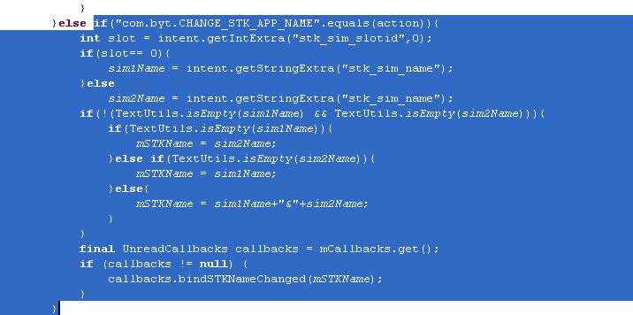
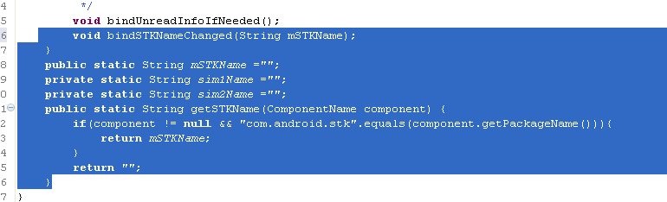
实现方法alps\packages\apps\Launcher3\src\com\android\launcher3\Launcher.java
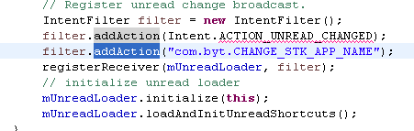
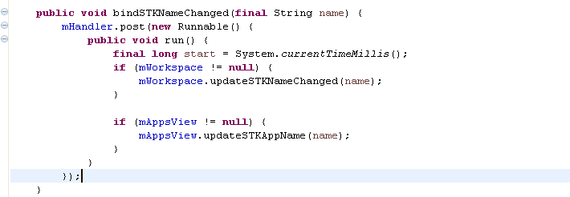
alps\packages\apps\Launcher3\src\com\android\launcher3\Workspace.java
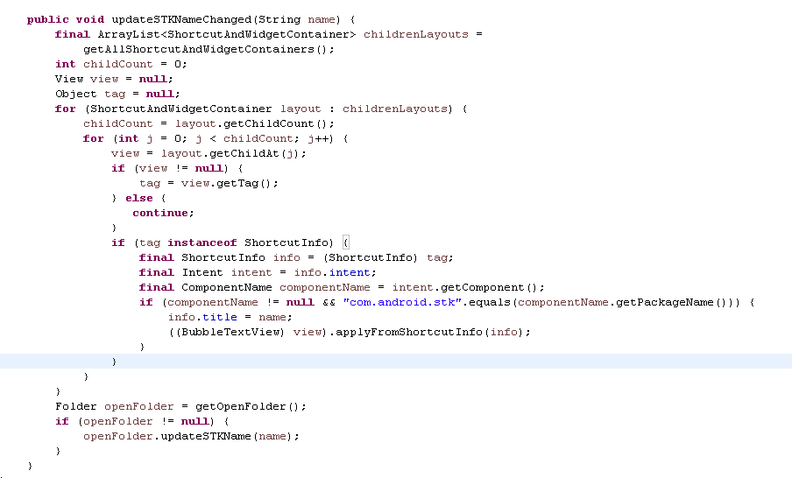
alps\packages\apps\Launcher3\src\com\android\launcher3\Folder.java
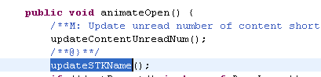
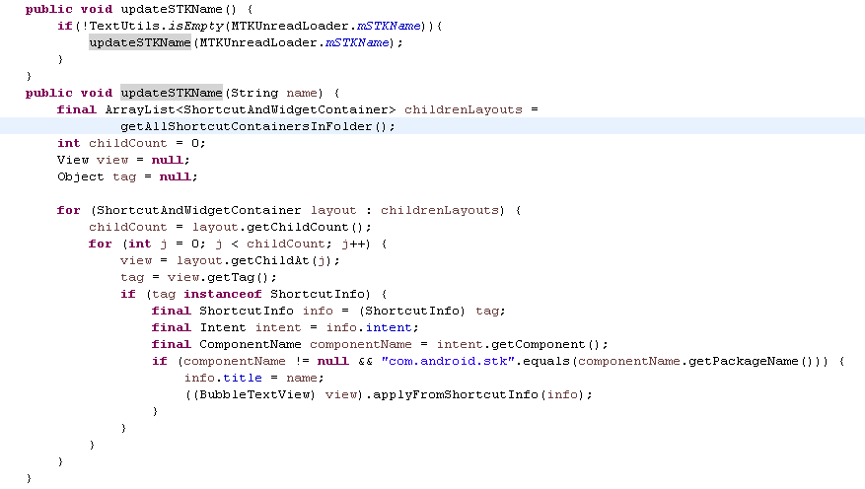
alps\packages\apps\Launcher3\src\com\android\launcher3\allapps\ AlphabeticalAppsList.java
public void updateApps(List<AppInfo> apps) {
……
for (int i = 0; i < size; i++) {
……
//add by byt start
String name = MTKUnreadLoader.getSTKName(appInfo.componentName);
if(!TextUtils.isEmpty(name)){
appInfo.title = name;
}
//add by byt end
}
……
}
alps\packages\apps\Launcher3\src\com\android\launcher3\ BubbleTextView.java
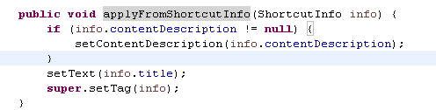
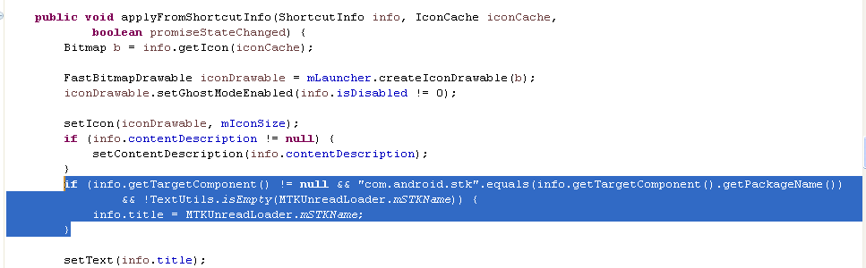
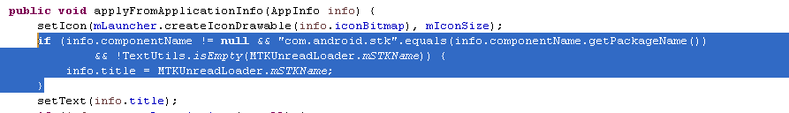

FAQ027：电量百分比显示
- 加菜单开关
alps\packages\apps\Settings\src\com\mediatek\settings\fuelgauge\ PowerUsageExts.java
在initPowerUsageExtItems()方法里面添加
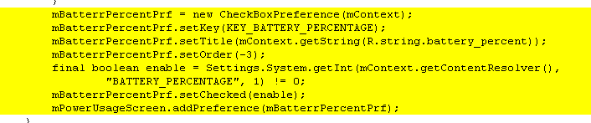
在onPowerUsageExtItemsClick()方法里面添加
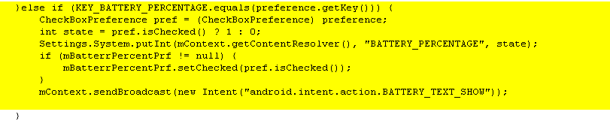
- 加界面显示百分比电量
alps\frameworks\base\packages\SystemUI\res\layout\ status_bar.xml
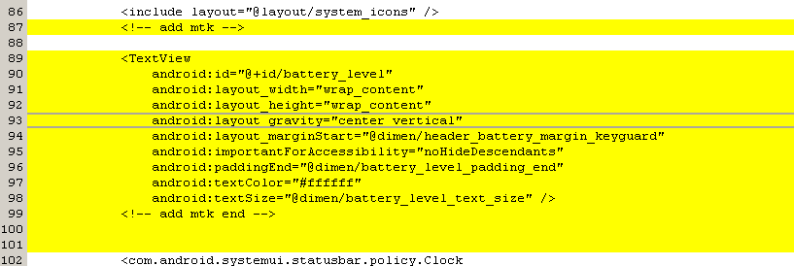
alps\frameworks\base\packages\SystemUI\src\com\android\systemui\statusbar\phone\ PhoneStatusBar.java
protected PhoneStatusBarView makeStatusBarView() {
……..
mBatteryController = new BatteryController(mContext);
mBatteryLevel = (TextView) mStatusBarView.findViewById(R.id.battery_level);
mBatteryController.addLabelView(mBatteryLevel);
………
}
alps\frameworks\base\packages\SystemUI\src\com\android\systemui\statusbar\policy\ BatteryController.java
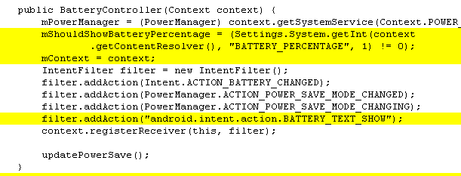
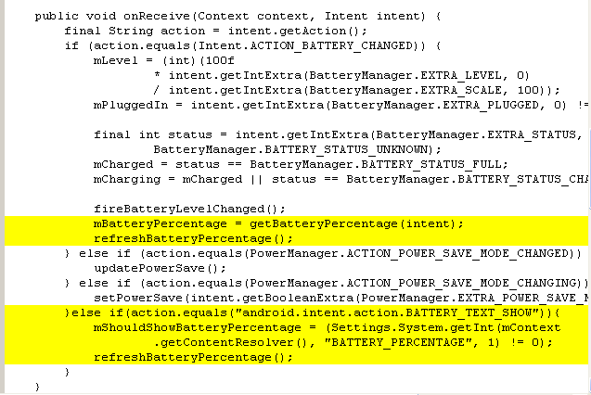
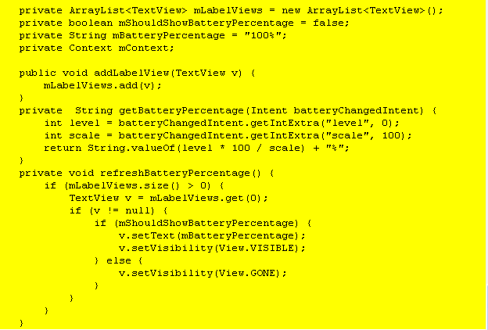
FAQ028：power键reboot、飞行模式、情景模式
alps\frameworks\base\core\res\res\values\ config.xml
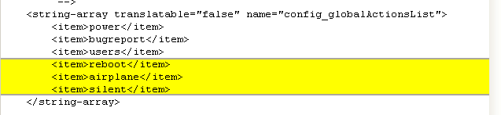
frameworks\base\services\core\java\com\android\server\policy\ GlobalActions.java
private static final String GLOBAL_ACTION_KEY_REBOOT = "reboot";\\add by byt
在createDialog()方法中添加
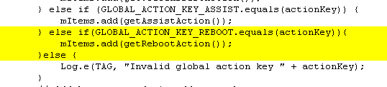
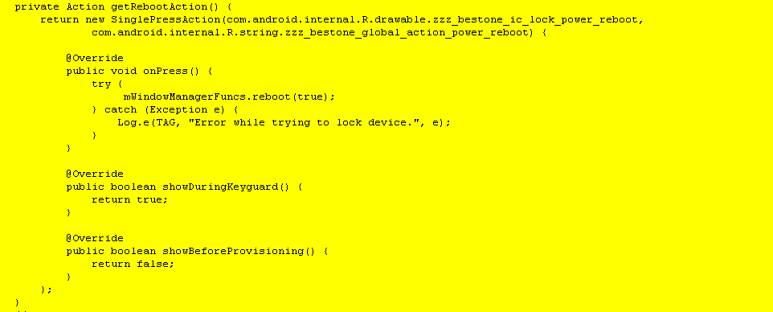
alps\frameworks\base\core\java\android\view\ WindowManagerPolicy.java
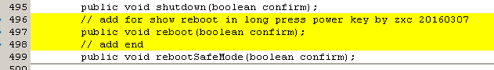
alps\frameworks\base\services\core\java\com\android\server\power\ ShutdownThread.java
主要修改reboot和shutdown显示的字符串
在shutdownInner方法里面
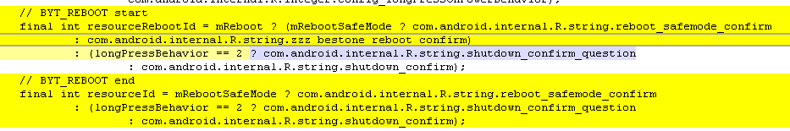
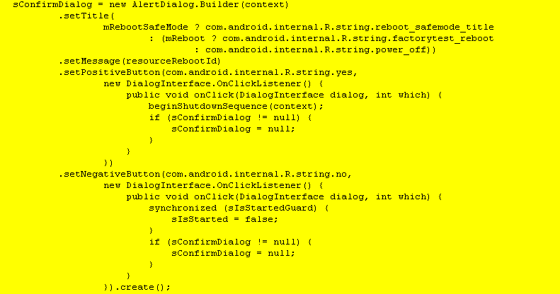
FAQ029：默认墙纸和墙纸列表
默认墙纸修改：alps\frameworks\base\core\res\res\ drawable-xxx\ default_wallpaper.jpg
drawable-xxx对应分辨率文件夹
添加墙纸：
alps\packages\apps\Launcher3\WallpaperPicker\res\values-nodpi\ wallpapers.xml
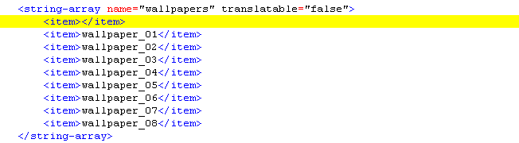
FAQ030：紧急号码
vendor\mediatek\proprietary\external\EccList\
修改对应xml里面内置的紧急号码。
如果要屏蔽sim自带的紧急号码修改：
alps\frameworks\base\telephony\java\android\telephony\ PhoneNumberUtils.java
在这个方法做处理
public static boolean isEmergencyNumberExt(String number, int phoneType) {
}

FAQ030：内置号码
ContentValues values = new ContentValues();
values.put(RawContacts.ACCOUNT_NAME, "Phone");
values.put(RawContacts.ACCOUNT_TYPE, "Local Phone Account");

Uri rawContentUri = context.getContentResolver().insert(RawContacts.CONTENT_URI, values);
long urirowid = ContentUris.parseId(rawContentUri);

//insert name and number
values.clear();
values.put(StructuredName.RAW_CONTACT_ID, urirowid);
values.put(Data.MIMETYPE, StructuredName.CONTENT_ITEM_TYPE);
values.put(StructuredName.DISPLAY_NAME, "Micromax Care");
context.getContentResolver().insert(Data.CONTENT_URI, values);

//inset number
values.clear();
values.put(Phone.RAW_CONTACT_ID, urirowid);
values.put(Data.MIMETYPE, Phone.CONTENT_ITEM_TYPE);
values.put(Phone.NUMBER, "18605008286");
context.getContentResolver().insert(Data.CONTENT_URI, values);

values.clear();
values.put(Phone.RAW_CONTACT_ID, urirowid);
values.put(Data.MIMETYPE, Email.CONTENT_ITEM_TYPE);
values.put(Email.TYPE, Email.TYPE_WORK);
values.put(Email.IS_PRIMARY, 1);
values.put(Email.ADDRESS, "service.superfone@micromaxinfo.com");
context.getContentResolver().insert(Data.CONTENT_URI, values);

FAQ030：内置群组
ContentValues values = new ContentValues();
values.put(RawContacts.ACCOUNT_NAME, "Phone");
values.put(RawContacts.ACCOUNT_TYPE, "Local Phone Account");
values.put(Groups.TITLE, GroupName);

final ContentResolver resolver = getContentResolver();
final Uri groupUri = resolver.insert(Groups.CONTENT_URI, values);

FAQ031：浏览器默认搜索引擎及定制搜索引擎
alps\vendor\mediatek\proprietary\frameworks\base\res\res\values-xx\ donottranslate-new-search_engines.xml
values-xx 代表对应的语言。donottranslate-new-search_engines.xml这个文件写在第一个代表默认的
FAQ032：默认小区广播频段及开关
开关在Modem里面打开，默认打开上层处理，关闭不需要处理
alps\vendor\mediatek\proprietary\packages\apps\Mms\src\com\mediatek\cb\cbsettings\ CellBroadcastActivity.java
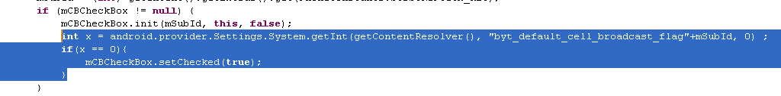
alps\vendor\mediatek\proprietary\packages\apps\Mms\src\com\mediatek\cb\cbsettings\ CellBroadcastCheckBox.java
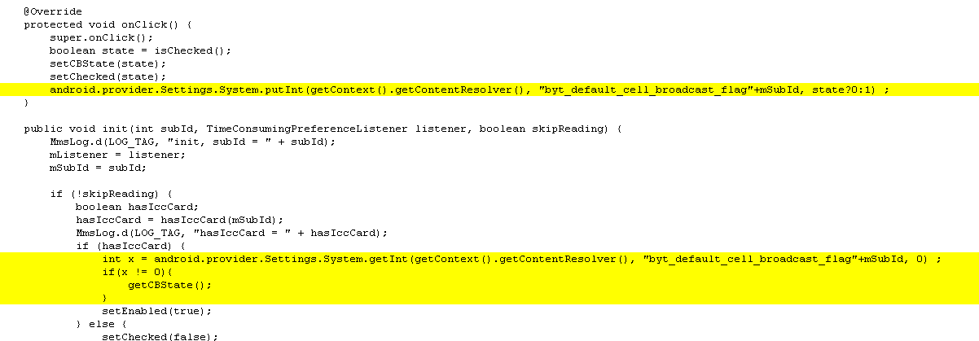
内置频道：
- 监听sim是否插入
alps\vendor\mediatek\proprietary\packages\apps\Mms\src\com\mediatek\cb\cbmsg\ CBMessageReceiver.java
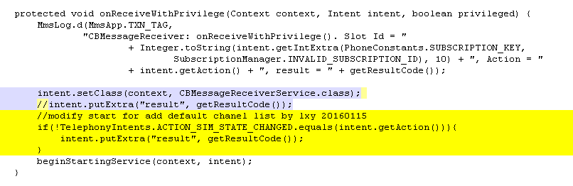
vendor\mediatek\proprietary\packages\apps\Mms\ AndroidManifest.xml
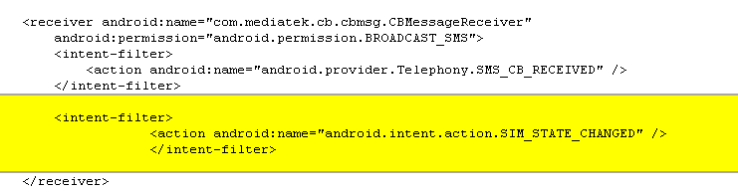
- 判断sim是否内置了小区广播没有就添加

alps\vendor\mediatek\proprietary\packages\apps\Mms\src\com\mediatek\cb\cbmsg\ CBMessageReceiverService.java
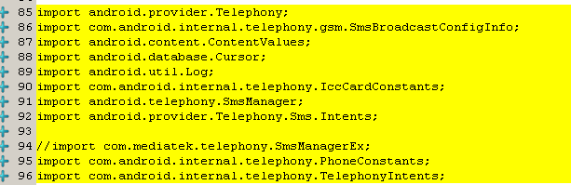
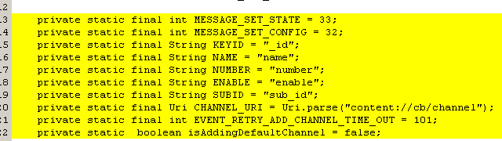
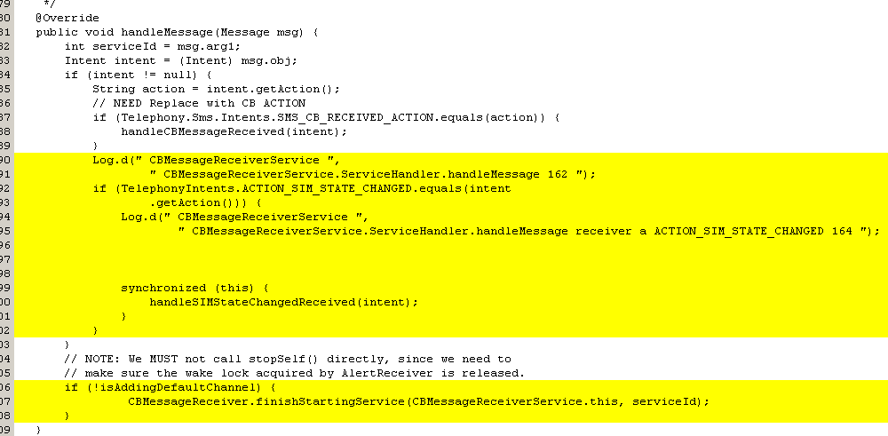
/*bestone add by zengxiao for CB chanel*/
//add 2015.10.30
private void handleSIMStateChangedReceived(Intent intent) {
Log.d(" CBMessageReceiverService ", " CBMessageReceiverService.handleSIMStateChangedReceived 191 "); // modify by mtk_debug 2015-3-05;
long subId = intent.getIntExtra(PhoneConstants.SUBSCRIPTION_KEY, SubscriptionManager.INVALID_SUBSCRIPTION_ID);
String stateExtra = intent.getStringExtra(IccCardConstants.INTENT_KEY_ICC_STATE);
// boolean stateExtra = intent.getBooleanExtra("ready",false);
Log.d(" CBMessageReceiverService ", " CBMessageReceiverService.handleSIMStateChangedReceived 214 stateExtra="+stateExtra);
if(IccCardConstants.INTENT_VALUE_ICC_READY.equals(stateExtra)){
// if(stateExtra){
if(queryIfChannelInDatabase(subId,"Canal 1",50))
{
Log.d(TAG, " CBMessageReceiverService.handleSIMStateChangedReceived subid="+subId+" channel1 50 in database");
isAddingDefaultChannel=false;
}else{
Log.d(" CBMessageReceiverService ", " CBMessageReceiverService.handleSIMStateChangedReceived subid="+subId+" channel1 50 not in database 699 "); // modify by mtk_debug 2015-3-02;
if(SmsManager.getSmsManagerForSubscriptionId((int)subId).activateCellBroadcastSms(true))
{
Log.d(TAG, " CBMessageReceiverService.handleSIMStateChangedReceived addCustomChanneltoList(subId,Channel1,50);");
addCustomChanneltoList(subId,"Canal 1(50)",50);
isAddingDefaultChannel=false;
}else{

Log.d(" CBMessageReceiverService ", " CBMessageReceiverService.handleSIMStateChangedReceived activateCellBroadcastSms fail 716 "); // modify by mtk_debug 2015-3-05;
//add retry
if (!mServiceHandler.hasMessages(EVENT_RETRY_ADD_CHANNEL_TIME_OUT)) {
Message msg = mServiceHandler.obtainMessage(EVENT_RETRY_ADD_CHANNEL_TIME_OUT,intent);
Log.d(" CBMessageReceiverService ", " CBMessageReceiverService.handleSIMStateChangedReceived send retry message 235 "); // modify by mtk_debug 2015-3-19;
mServiceHandler.sendMessageDelayed(msg, 2000);
isAddingDefaultChannel=true;
}

}

}
/* add channel 50
if(queryIfChannelInDatabase(subId,"Channel2",50))
{
Log.d(TAG, " CBMessageReceiverService.handleSIMStateChangedReceived subid="+subId+" channel2 50 in database");
//return;
}else{
Log.d(" CBMessageReceiverService ", " CBMessageReceiverService.handleSIMStateChangedReceived subid="+subId+" channel2 50 not in database 699 "); // modify by mtk_debug 2015-3-02;
if(SmsManager.getSmsManagerForSubscriptionId(subId).activateCellBroadcastSms(true))
{
Log.d(TAG, " CBMessageReceiverService.handleSIMStateChangedReceived addCustomChanneltoList(subId,Channel2,50);");
addCustomChanneltoList(subId,"Canal 1(50)",50);
}else{

Log.d(" CBMessageReceiverService ", " CBMessageReceiverService.handleSIMStateChangedReceived activateCellBroadcastSms false 716 "); // modify by mtk_debug 2015-3-05;
}

}

*/
//add channel 919
if(queryIfChannelInDatabase(subId,"Canal 2",919))
{
Log.d(TAG, " CBMessageReceiverService.handleSIMStateChangedReceived subid="+subId+" channel2 919 in database");
//return;
}else{
Log.d(" CBMessageReceiverService ", " CBMessageReceiverService.handleSIMStateChangedReceived subid="+subId+" channel2 919 not in database 699 "); // modify by mtk_debug 2015-3-02;
if(SmsManager.getSmsManagerForSubscriptionId((int)subId).activateCellBroadcastSms(true))
{
Log.d(TAG, " CBMessageReceiverService.handleSIMStateChangedReceived addCustomChanneltoList(subId,Channel2,919);");
addCustomChanneltoList(subId,"Canal 2(919)",919);
}else{

Log.d(" CBMessageReceiverService ", " CBMessageReceiverService.handleSIMStateChangedReceived activateCellBroadcastSms false 716 "); // modify by mtk_debug 2015-3-05;
}

}
//add channel 921
if(queryIfChannelInDatabase(subId,"Canal 3",921))
{
Log.d(TAG, " CBMessageReceiverService.handleSIMStateChangedReceived subid="+subId+" channel2 921 in database");
//return;
}else{
Log.d(" CBMessageReceiverService ", " CBMessageReceiverService.handleSIMStateChangedReceived subid="+subId+" channel2 921 not in database 699 "); // modify by mtk_debug 2015-3-02;
if(SmsManager.getSmsManagerForSubscriptionId((int)subId).activateCellBroadcastSms(true))
{
Log.d(TAG, " CBMessageReceiverService.handleSIMStateChangedReceived addCustomChanneltoList(subId,Channel2,921);");
addCustomChanneltoList(subId,"Canal 3(921)",921);
}else{

Log.d(" CBMessageReceiverService ", " CBMessageReceiverService.handleSIMStateChangedReceived activateCellBroadcastSms false 716 "); // modify by mtk_debug 2015-3-05;
}

}
//add channel 4370
if(queryIfChannelInDatabase(subId,"Canal 4",4370))
{
Log.d(TAG, " CBMessageReceiverService.handleSIMStateChangedReceived subid="+subId+" channel2 4370 in database");
//return;
}else{
Log.d(" CBMessageReceiverService ", " CBMessageReceiverService.handleSIMStateChangedReceived subid="+subId+" channel2 4370 not in database 699 "); // modify by mtk_debug 2015-3-02;
if(SmsManager.getSmsManagerForSubscriptionId((int)subId).activateCellBroadcastSms(true))
{
Log.d(TAG, " CBMessageReceiverService.handleSIMStateChangedReceived addCustomChanneltoList(subId,Channel2,4370);");
addCustomChanneltoList(subId,"Canal 4(4370)",4370);
}else{

Log.d(" CBMessageReceiverService ", " CBMessageReceiverService.handleSIMStateChangedReceived activateCellBroadcastSms false 716 "); // modify by mtk_debug 2015-3-05;
}

}

}

}

private void addCustomChanneltoList(long mSubId,String channelName,int channelNum){
Log.d(TAG, "addCustomChanneltoList: mSubId=" + mSubId
+ ", channelName= " + channelName + ", channelNum= " + channelNum);

SmsBroadcastConfigInfo[] objectList = new SmsBroadcastConfigInfo[1];
objectList[0] = new SmsBroadcastConfigInfo(channelNum,channelNum, -1, -1, true);

Log.d(TAG, "addCustomChanneltoList: setCellBroadcastSmsConfig");
//SmsManagerEx.getDefault().setCellBroadcastSmsConfig(objectList, objectList, mSimId);
boolean isSetConfigSuccess = SmsManager.getSmsManagerForSubscriptionId((int)mSubId).setCellBroadcastSmsConfig(objectList, objectList);
if(isSetConfigSuccess){
Log.d(" CBMessageReceiverService ", " CBMessageReceiverService.addCustomChanneltoList set channel " +channelNum +" success 784 "); // modify by mtk_debug 2015-3-05;
addChannelToDatabase(mSubId,channelName,channelNum);
}else{
Log.d(" CBMessageReceiverService ", " CBMessageReceiverService.addCustomChanneltoList set channel "+ channelNum +" failed 786 "); // modify by mtk_debug 2015-3-05;
}

Log.d(TAG, " CBMessageReceiverService addCustomChanneltoList: function end");
}

private boolean addChannelToDatabase(long mSubId,String channelName,int channelNum){
// ClearChannel();
Log.d(TAG, "addChannelToDatabase: mSubId=" + mSubId
+ ", channelName= " + channelName + ", channelNum= " + channelNum);
String[] projection = new String[] { NUMBER, SUBID};
String SELECTIONNum = "(" + NUMBER + " = " + channelNum + ")";
String SELECTIONid = "(" + SUBID + " = " + mSubId + ")";
Cursor cursornum = null;
Cursor cursorid = null;

Cursor cursorzz = this.getContentResolver().query(CHANNEL_URI,
projection,
NUMBER + " = ? AND " +
SUBID + " = ?",
new String[] {String.valueOf(channelNum), String.valueOf(mSubId)},
null);
Log.d(TAG, "addChannelToDatabase: cursor.getCount"+cursorzz.getCount());
if(cursorzz.getCount() == 0){//if ((cursornum.getCount() == 0)&&(cursorid.getCount() == 0)){
Log.d(" CBMessageReceiverService ", " SmsReceiverService.addChannelToDatabase add mSubId=" + mSubId
+ ", channelName= " + channelName + ", channelNum= " + channelNum +"to database"); // modify by mtk_debug 2015-3-05;
ContentValues values = new ContentValues();
values.put(NAME,channelName);
values.put(NUMBER, channelNum);
values.put(ENABLE, true);
values.put(SUBID, mSubId);
try {
//if(mSimId==PhoneConstants.SUB1){
this.getContentResolver().insert(CHANNEL_URI, values);
//}else if(mSimId==PhoneConstants.SUB2){
// this.getContentResolver().insert(CHANNEL_URI1, values);
//}
} catch (Exception e){
Log.d(" CBMessageReceiverService ", " SmsReceiverService.addChannelToDatabase exception 828 "); // modify by mtk_debug 2015-3-05;
//cursornum.close();
//cursorid.close();
cursorzz.close();
return false;
}
//cursornum.close();
// cursorid.close();
cursorzz.close();
return true;
}
else{
//cursornum.close();
//cursorid.close();
cursorzz.close();
return false;
}

}

private boolean queryIfChannelInDatabase(long mSubId,String channelName,int channelNum){

Log.d(TAG, "queryIfChannelInDatabase: mSubId=" + mSubId
+ ", channelName= " + channelName + ", channelNum= " + channelNum);
String[] projection = new String[] { NUMBER, SUBID};
String SELECTIONNum = "(" + NUMBER + " = " + channelNum + ")";
String SELECTIONid = "(" + SUBID + " = " + mSubId + ")";
Cursor cursornum = null;
Cursor cursorid = null;

Cursor cursorzz = this.getContentResolver().query(CHANNEL_URI,
projection,
NUMBER + " = ? AND " +
SUBID + " = ?",
new String[] {String.valueOf(channelNum),String.valueOf(mSubId)},
null);

if(cursorzz != null&&cursorzz.getCount() > 0){
//if ((cursornum.getCount() != 0)&&(cursorid.getCount() != 0)){
Log.d(TAG, "queryIfChannelInDatabase: cursor.getCount"+cursorzz.getCount());
cursorzz.close();
return true;

}else{
cursorzz.close();
Log.d(TAG, "queryIfChannelInDatabase: return false");
return false;
}

}

/*bestone add end*/

FAQ033：默认短信彩信单双卡报告开关
修改默认值需要注意单双卡使用的xml文件是不同的，所以除了修改所有xml对应的pref_key_mms_delivery_reports key对应的默认值，还需要修改代码获取这个key的赋值，例如：
alps\vendor\mediatek\proprietary\packages\apps\Mms\src\com\mediatek\setting\ MmsPreferenceActivity.java
if (mMmsDeliveryReport != null) {
mMmsDeliveryReport.setChecked(sp.getBoolean(mMmsDeliveryReport.getKey(), /*false*/true));
}
修改restoreDefaultPreferences(){}方法中
editor.putBoolean(Long.toString(subId) + "_" + MMS_DELIVERY_REPORT_MODE, /*false*/true);
alps\vendor\mediatek\proprietary\packages\apps\Mms\src\com\mediatek\setting\ SubSelectAdapter.java
public boolean isChecked(int position) {
SharedPreferences prefs = PreferenceManager.getDefaultSharedPreferences(mContext);
boolean defaultValue = false;
if (MmsPreferenceActivity.AUTO_RETRIEVAL.equals(mPreferenceKey)) {
defaultValue = true;
}
return prefs.getBoolean(Long.toString((mList.get(position)).getSubscriptionId()) + "_"
+ mPreferenceKey,
defaultValue);
}
FAQ034：7Bit
frameworks\base\telephony\java\com\android\internal\telephony\ GsmAlphabet.java
static {
enableCountrySpecificEncodings();
………..
//add by byt start
SparseIntArray defaultCharToGsm = sCharsToGsmTables[0];
defaultCharToGsm.put('\u00C1', 0x41);
defaultCharToGsm.put('\u00C0', 0x41);
defaultCharToGsm.put('\u00E1', 0x61);
defaultCharToGsm.put('\u00E0', 0x61);

defaultCharToGsm.put('\u00C8', 0x45);
defaultCharToGsm.put('\u00E8', 0x65);

defaultCharToGsm.put('\u00CD', 0x49);
defaultCharToGsm.put('\u00CC', 0x49);
defaultCharToGsm.put('\u00CF', 0x49);
defaultCharToGsm.put('\u00ED', 0x69);
defaultCharToGsm.put('\u00EC', 0x69);
defaultCharToGsm.put('\u00EF', 0x69);

defaultCharToGsm.put('\u00D3', 0x4F);
defaultCharToGsm.put('\u00D2', 0x4F);
defaultCharToGsm.put('\u00F3', 0x6F);
defaultCharToGsm.put('\u00F2', 0x6F);

defaultCharToGsm.put('\u00D9', 0x55);
defaultCharToGsm.put('\u00DA', 0x55);
defaultCharToGsm.put('\u00DC', 0x55);
defaultCharToGsm.put('\u00F9', 0x75);
defaultCharToGsm.put('\u00FA', 0x75);
defaultCharToGsm.put('\u00FC', 0x75);

defaultCharToGsm.put('\u00C7', 0x43);
defaultCharToGsm.put('\u00E7', 0x63);
//add end

sCharsToShiftTables = new SparseIntArray[numTables];
……..
}
FAQ035：彩信默认附件大小
修改文件：
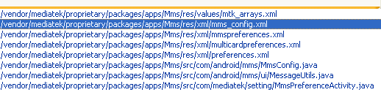
修改添加一个彩信附件大小并默认：
mtk_arrays.xml
<string-array name="pref_mms_size_limit_choices" translatable="false">
<item>100K</item>
<item>200K</item>
<item>600K</item>
</string-array>
<string-array name="pref_mms_size_limit_values" translatable="false">
<item>100</item>
<item>200</item>
<item>600</item>
</string-array>
mms_confg.xml
<int name="maxMessageSize">614400</int>
mmspreferences.xml
<ListPreference android:key="pref_key_mms_size_limit"
android:title="@string/pref_title_mms_size_limit"
android:dialogTitle="@string/pref_title_mms_size_limit"
android:summary="@string/pref_summary_mms_size_limit"
android:defaultValue="600" android:entries="@array/pref_mms_size_limit_choices"/>
multicardpreferences.xml
<ListPreference
android:key="pref_key_mms_size_limit"
android:title="@string/pref_title_mms_size_limit"
android:dialogTitle="@string/pref_title_mms_size_limit"
android:summary="@string/pref_summary_mms_size_limit"
android:defaultValue="600"
android:entries="@array/pref_mms_size_limit_choices"
android:entryValues="@array/pref_mms_size_limit_values"/>
preferences.xml
<ListPreference
android:key="pref_key_mms_size_limit"
android:title="@string/pref_title_mms_size_limit"
android:dialogTitle="@string/pref_title_mms_size_limit"
android:summary="@string/pref_summary_mms_size_limit"
android:defaultValue="600"
android:entries="@array/pref_mms_size_limit_choices"
android:entryValues="@array/pref_mms_size_limit_values"/>
MmsConfig.java
private static int mMaxMessageSize = 600 * 1024;
MessageUntils.java
public static void setMmsLimitSize(Context context) {
…….
if (sp != null) {
mSizeLimitTemp = sp.getString("pref_key_mms_size_limit", "600");
}
if (mSizeLimitTemp != null && 0 == mSizeLimitTemp.compareTo("100")) {
mMmsSizeLimit = 100;
} else if (mSizeLimitTemp != null && 0 == mSizeLimitTemp.compareTo("200")) {
mMmsSizeLimit = 200;
} else {
mMmsSizeLimit = 600;
}
…….
}
MmspreferenceActivity.java
private static final String SIZE_LIMIT_600 = "600";
private void setListPrefSummary() {
…..
mSizeLimitTemp = sp.getString("pref_key_mms_size_limit", "600");
…..
}
private void restoreDefaultPreferences() {
……
editor.putString(MMS_SIZE_LIMIT, SIZE_LIMIT_600);
……
}
FAQ036：通话耳机键挂断电话
alps\packages\services\Telecomm\src\com\android\server\telecom\ CallsManager.java
boolean onMediaButton(int type) {
…….
Call ringingCall = getFirstCallWithState(CallState.RINGING);
if (ringingCall == null) {
//add by byt start
Call callToHangup = getFirstCallWithState(
CallState.RINGING, CallState.DIALING, CallState.ACTIVE, CallState.ON_HOLD);
if (callToHangup != null) {
disconnectCall(callToHangup);
return true;
}
//add end
mCallAudioManager.toggleMute();
return true;
}
……
}
FAQ037：默认4:3还是全屏
alps\vendor\mediatek\proprietary\packages\apps\Camera\src\com\mediatek\camera\setting\ SettingUtils.java
public static void initialCameraPictureSize(Context context, Parameters parameters,
SharedPreferences sharedPreferences) {
…….
String ratioString = sharedPreferences.getString(SettingConstants.KEY_PICTURE_RATIO, null);//改成默认的
………
}
alps\vendor\mediatek\proprietary\packages\apps\Camera\src\com\android\camera\bridge\ CameraDeviceExt.java
public void setPreviewSize() {
String pictureRatio = mPreferences.getString(SettingConstants.KEY_PICTURE_RATIO, null); //改成默认的
……
}

FAQ038：差值
驱动在配置里面加。
MMI需要添加的文件：
alps\vendor\mediatek\proprietary\packages\apps\Camera\res\values\arrays.xml
显示名称
<string-array name="pref_camera_picturesize_entries" translatable="false">
</string-array>
像素要跟名称位置对应
<string-array name="pref_camera_picturesize_entryvalues" translatable="false">
</string-array>
alps\vendor\mediatek\proprietary\packages\apps\Camera\src\com\mediatek\camera\setting\SettingDataBase.java
将添加的像素加到相对应的数组里面：PICTURE_SIZE_4_3、PICTURE_SIZE_16_9、PICTURE_SIZE_5_3、PICTURE_SIZE_3_2，例如320x240 320/240 =4/3,所以加到PICTURE_SIZE_4_3

FAQ039：相机设置添加 、删除一个item

删除Item
alps\vendor\mediatek\proprietary\packages\apps\Camera\src\com\mediatek\camera\setting\ SettingGenerator.java

在下面方法中过滤掉。
private boolean filterPreference(final ListPreference preference) {
}
添加Item
alps\vendor\mediatek\proprietary\packages\apps\Camera\res\xml\ camera_preferences.xml
添加一个显示的preference
<ListPreference
camera:key="pref_volume_key"
camera:defaultValue="@string/pref_volume_key_default"
camera:title="@string/pref_volume_key_sound_title"
camera:entries="@array/pref_camera_shutter_sound_entries"
camera:entryValues="@array/pref_camera_shutter_sound_entryvalues"/>
alps\vendor\mediatek\proprietary\packages\apps\Camera\src\com\mediatek\camera\setting\ SettingContants.java
public static final String KEY_VILUME_KEY = "pref_volume_key";
public static final int ROW_KEY_VILUME_KEY = 62;
public static final int SETTING_COUNT = 63;

KEYS_FOR_SETTING[ROW_KEY_VILUME_KEY] = KEY_VILUME_KEY;

将ROW_KEY_VILUME_KEY 加到这种格式的数组里面，说明这个菜单在camera列表里面public static final int[] SETTING_GROUP_CAMERA_FOR_xxx={}
alps\vendor\mediatek\proprietary\packages\apps\Camera\src\com\mediatek\camera\setting\ SettingDataBase.java
设置参数
MATRIX_RESTRICTION_STATE[SettingConstants.ROW_KEY_VILUME_KEY] = new int[] {
STATE_E0, STATE_E0, STATE_E0, STATE_R0, STATE_R0, STATE_E0, STATE_R0, STATE_R0,
STATE_E0, STATE_E0, STATE_R0, STATE_E0, STATE_E0, STATE_E0
};
添加到恢复列表里面写默认值
private static final int[] RESTRCTION_SETTING_INDEX = new int[] {
…..
SettingConstants.ROW_KEY_VILUME_KEY,
}
RESET_STATE_VALUE[SettingConstants.ROW_KEY_VILUME_KEY] = new String[] {
"off", "on"
};
DEFAULT_VALUE_FOR_SETTING[SettingConstants.ROW_KEY_VILUME_KEY] = "on";
是否显示IconPreference:
alps\vendor\mediatek\proprietary\packages\apps\Camera\src\com\android\camera\ui\SettingsListLayout
private boolean isSwitchSettingItem(ListPreference pref) {
return SettingConstants.KEY_VILUME_KEY.equals(pref.getKey())
||……..
}

FAQ040：照片信息maker，model信息
alps\packages\apps\Gallery2\src\com\android\gallery3d\ui\ DialogDetailsView.java
private void setDetails(Context context, MediaDetails details) {
……
if (details.hasUnit(key)) {
value = String.format("%s: %s %s", DetailsHelper.getDetailsName(
context, key), value, context.getString(details.getUnit(key)));
} else {
//modify by byt start
String mDefaultModemName = SystemProperties.get("ro.byt.gallery.maker.name");
String mDefaultModemNumber = SystemProperties.get("ro.byt.gallery.model.name");
if(mDefaultModemName.isEmpty() || mDefaultModemNumber.isEmpty()){
value = String.format("%s: %s", DetailsHelper.getDetailsName(
context, key), value);
}else{
value = String.format("%s: %s", DetailsHelper.getDetailsName(context, key), (MediaDetails.INDEX_MAKE==key || MediaDetails.INDEX_MODEL==key)?((MediaDetails.INDEX_MAKE==key)?mDefaultModemName:mDefaultModemNumber): value);
}
/// modify end
}
}
可以在alps\build\tools\ buildinfo.sh修改
ro.byt.gallery.maker.name与ro.byt.gallery.model.name的值。
FAQ041：email默认签名
alps/packages/apps/Email/emailcommon/src/com/android/emailcommon/provider/Account.java
FAQ042:voice control默认为英文
vendor/mediatek/proprietary/packages/apps/VoiceCommand/res/xml/voicecustomization.xml
<VoiceCustomization SystemLanguage="TRUE" DefaultLanguage="en-US" />
vendor/mediatek/proprietary/packages/apps/VoiceCommand/res/xml/voicelanguage.xml <DefaultLanguage ID="3" />
FAQ043:情节模式需要支持外部铃声
- alps/vendor/mediatek/proprietary/packages/apps/Mms/src/com/android/mms/transaction/MessagingNotification.java
在sNotificationPlayer.stop();后面加上 String baseText = "content://settings/system/notification_sound";
Ringtone tone = ringtoneUri != null ? RingtoneManager.getRingtone(context, ringtoneUri) : null;
String titleText = tone != null ? tone.getTitle(context) : "";

Uri threadRingUri = Uri.parse(notiProf.getThreadRingeStr());
Ringtone threadTone = threadRingUri != null ? RingtoneManager.getRingtone(context, threadRingUri) : null;
String threadTitleText = tone != null ? threadTone.getTitle(context) : "";

Uri appRingUri = Uri.parse(notiProf.getAppRingeStr());
Ringtone appTone = appRingUri != null ? RingtoneManager.getRingtone(context, appRingUri) : null;
String appTitleText = tone != null ? appTone.getTitle(context) : "";

if(TextUtils.isEmpty(threadTitleText) || threadTitleText.equals(context.getString(com.android.internal.R.string.ringtone_unknown))){
if(titleText.equals(ringtoneUri.getLastPathSegment())) {
ringtoneStr = baseText;
}
}else{
if(titleText.equals(threadRingUri.getLastPathSegment())) {
if(appTitleText.equals(appRingUri.getLastPathSegment())) {
ringtoneStr = baseText;
}else{
ringtoneStr = notiProf.getAppRingeStr();
}
}
}

ringtoneUri = Uri.parse(ringtoneStr);
也要加上两个接口：import android.media.Ringtone;
import android.media.RingtoneManager;
- /alps/vendor/mediatek/proprietary/packages/apps/Mms/src/com/mediatek/setting/NotificationPreferenceActivity.java
在 mRingtonePref.setSummary(tone != null ? tone.getTitle(this)
: getResources().getString(R.string.silent_ringtone));后面加上
if(soundUri != null && tone != null){
if(tone.getTitle(this).equals(soundUri.getLastPathSegment())){
String baseText = "content://settings/system/notification_sound";
Uri ringtoneUri = Uri.parse(baseText);
Ringtone appTone = ringtoneUri != null ? RingtoneManager.getRingtone(this, ringtoneUri) : null;
String titleText = tone != null ? appTone.getTitle(this) : "";

mRingtonePref.setSummary(TextUtils.isEmpty(titleText) ?
getResources().getString(R.string.pref_summary_notification_ringtone) : titleText);
}
}
- /alps/packages/providers/MediaProvider/src/com/android/providers/media/RingtonePickerActivity.java 把 private boolean mHasMoreRingtonesItem = false;改成private boolean mHasMoreRingtonesItem = true; 把mHasMoreRingtonesItem = intent.getBooleanExtra(
RingtoneManager.EXTRA_RINGTONE_SHOW_MORE_RINGTONES, false);改成i f(mHasMoreRingtonesItem){
}else{
mHasMoreRingtonesItem = intent.getBooleanExtra(
RingtoneManager.EXTRA_RINGTONE_SHOW_MORE_RINGTONES, false);
}
在 MtkLog.v(TAG, "onActivityResult: RESULT_OK, so set to be ringtone! "
+ uri);后面加上
mClickedPos = getListPosition(mRingtoneManager.getRingtonePosition(uri));
Intent resultIntent = new Intent();
resultIntent.putExtra(RingtoneManager.EXTRA_RINGTONE_PICKED_URI, uri);
setResult(RESULT_OK, resultIntent);
getWindow().getDecorView().post(new Runnable() {
public void run() {
mCursor.deactivate();
}
});

this.finish();
FAQ044：短信显示时间和日期
/alps/vendor/mediatek/proprietary/packages/apps/Mms/src/com/android/mms/ui/MessageUtils.java
把
if (then.year != now.year) {
format_flags |= DateUtils.FORMAT_SHOW_YEAR | DateUtils.FORMAT_SHOW_DATE;
} else if (then.yearDay != now.yearDay) {
// If it is from a different day than today, show only the date.
format_flags |= DateUtils.FORMAT_SHOW_DATE;
} else {
// Otherwise, if the message is from today, show the time.
format_flags |= DateUtils.FORMAT_SHOW_TIME;
}
改成
if (then.year != now.year) {
format_flags |= DateUtils.FORMAT_SHOW_YEAR | DateUtils.FORMAT_SHOW_DATE;
} else if (then.yearDay != now.yearDay) {
// If it is from a different day than today, show only the date.
If(SMS_SHOW_DATE_AND_TIME){
format_flags |= DateUtils.FORMAT_SHOW_DATE | DateUtils.FORMAT_SHOW_TIME;
}else{
format_flags |= DateUtils.FORMAT_SHOW_DATE;
}
} else {
// Otherwise, if the message is from today, show the time.
format_flags |= DateUtils.FORMAT_SHOW_TIME;
}
并且定义变量：public static final boolean SMS_SHOW_DATE_AND_TIME =true;

FAQ045：滑动锁屏状态下禁止下拉状态栏
NotificationPanelView.java(alps/frameworks/base/packages/SystemUI/src/com/android/systemui/statusbar/phone/NotificationPanelView.java)中的两个方法。
（1）
private void setQsExpanded(boolean expanded) {
//begin 添加下面四行
if(mKeyguardShowing)
{
return;
}
//end
boolean changed = mQsExpanded != expanded;
if (changed) {
mQsExpanded = expanded;
updateQsState();
requestPanelHeightUpdate();
mNotificationStackScroller.setInterceptDelegateEnabled(expanded);
mStatusBar.setQsExpanded(expanded);
}
}
(2)
private boolean shouldQuickSettingsIntercept(float x, float y, float yDiff) {
if (!mQsExpansionEnabled) {
return false;
}
//begin 将下面第一行替换成第二行
View header = mKeyguardShowing ? mKeyguardStatusBar : mHeader;
View header = mHeader;
//end
boolean onHeader = x >= header.getLeft() && x <= header.getRight()
&& y >= header.getTop() && y <= header.getBottom();
if (mQsExpanded) {
return onHeader || (mScrollView.isScrolledToBottom() && yDiff < 0) && isInQsArea(x, y);
} else {
return onHeader;
}
}

(3) private boolean onTouchEvent()
{
...
if (!mTwoFingerQsExpand && mQsTracking) {
//begin 添加下面红色的两行
if(!mKeyguardShowing){
onQsTouch(event);
if (!mConflictingQsExpansionGesture) {
return true;
}
}
//end
}
...
}
FAQ046:关闭来电归属地
packages/apps/Dialer/src/com/android/dialer/CallDetailActivity.java 在 if (!TextUtils.isEmpty(callLocationOrType)) 之后加上 mCallerNumber.setVisibility(View.GONE);
FAQ047:取消录像按键音
alps\packages\apps\Camera\src\com\android\camera\SettingChecker.java文件中的setParameterValue()函数内:
case ROW_SETTING_MUTE_RECORDING_SOUND:
Log.i(TAG, "enableRecordingSound value = " + value);
parameters.enableRecordingSound(value);
修改为
case ROW_SETTING_MUTE_RECORDING_SOUND:
Log.i(TAG, "enableRecordingSound value = " + value);
parameters.enableRecordingSound(1);
FAQ047:修改日历和时钟小部件的时间完整
alps\vendor\mediatek\proprietary\packages\apps\Calendar\src\com\android\calendar\widget\CalendarAppWidgetProvider.java
final String dayOfWeek = DateUtils.getDayOfWeekString(time.weekDay + 1,
DateUtils.LENGTH_SHORT);改成final String dayOfWeek = DateUtils.getDayOfWeekString(time.weekDay + 1,
DateUtils.LENGTH_LONG);
alps\packages\apps\DeskClock\src\com\android\alarmclock\DigitalAppWidgetProvider.java
把final CharSequence dateFormat = Utils.isJBMR2OrLater()
? DateFormat.getBestDateTimePattern(Locale.getDefault(),
context.getString(R.string.abbrev_wday_month_day_no_year))
: ((SimpleDateFormat) SimpleDateFormat.getDateInstance(SimpleDateFormat.SHORT))
.toPattern();改成final CharSequence dateFormat = Utils.isJBMR2OrLater()
? DateFormat.getBestDateTimePattern(Locale.getDefault(),
context.getString(R.string.full_wday_month_day_no_year))
: ((SimpleDateFormat) SimpleDateFormat.getDateInstance(SimpleDateFormat.SHORT))
.toPattern();

FAQ048：内置联系人及邮箱
alps/packages/apps/Dialer/src/com/android/dialer/calllog/CallLogReceiver.java
FAQ049：隐藏小部件
- 有源码：
直接在AndroidManifest.xml中把APPWidghet删掉即可！
- 只有apk
alps/packages/apps/Launcher3/src/com/android/launcher3/model/WidgetsModel.java
中的 pInfo.titleSectionName = mIndexer.computeSectionName(pInfo.title);后面加上 if(packageName.equals("包名"))
{
Log.d("zhaotang","fota = "+pInfo.toString());
continue ;
}
FAQ050:在电池低电压时，如何关闭camera的闪光功能
在alps\packages\apps\Camera\src\com\android\camera\Camera.java中做如下修改：

1. 接受Battery的intent, 例如
registerForBroadcasts()
{
IntentFilter intentfilter = new IntentFilter();
intentFilter.addAction(Intent.ACTION_BATTERY_CHANGED);
mContext.registerReceiver(mReceiver, intentFilter);
}
2. 接受Battery的电压值
private final BroadcastReceiver mReceiver = new BroadReceiver()
{
@override
public void onReceive(Contect contect, Intent intent)
{
String action = intent.getAction();
if(action.equals(Intent.ACTION_BATTERY_CHANGED))
{
int vBat = intent.getIntExtra("voltage", 0);
//这里就获取到电池的电压值， 单位是mV
//可以利用这个电池电压进行判断来决定是否Camera这边需要关闭闪光灯
mParameters.setFlashMode(Parameters.FLASH_MODE_OFF);
applyParametersToServer();
}
}
}

FAQ051:调整状态栏icon之间的显示顺序
alps/frameworks/base/res/res/values/config.xml
中的config_statusBarIcons调整相应的顺序，其中从上倒下，对应的状态栏的顺序为从左到右
FAQ052:联系人列表中如何去掉机主信息“我”
路径：alps\packages\apps\Contacts\src\com\android\contacts\list
修改 DefaultContactBrowseListFragment.java 的 showEmptyUserProfile() 方法。
private void showEmptyUserProfile(boolean show) {
mProfileTitle.setVisibility(show ? View.VISIBLE : View.GONE);
mProfileMessage.setVisibility(show ? View.VISIBLE : View.GONE);
改为
mProfileTitle.setVisibility(show ? View.GONE : View.GONE);
mProfileMessage.setVisibility(show ? View.GONE : View.GONE);
FAQ053:如何设置屏幕亮度默认值为自动调节
修改
alps\frameworks\base\packages\SettingsProvider\res\values\defaults.xml
内的
<bool name="def_screen_brightness_automatic_mode">false</bool>
改为
<bool name="def_screen_brightness_automatic_mode">true</bool>
即可。
FAQ054：如何把"设置--安全--未知来源“默认打开
alps\frameworks\base\packages\settingsprovider\res\values\Defaults.xml
中
<bool name="def_install_non_market_apps">false</bool>
为
<bool name="def_install_non_market_apps">true</bool>
注意，修改后可能导致CTS无法通过，请酌情修改。

FAQ055:连接wifi后，去掉弹出对话框中的"Forget"按钮
alps\packages\apps\Settings\src\com\android\settings\wifi\WifiDialog.java 把
if (mHideForgetButton) {
mController.hideForgetButton();
}改成
mController.hideForgetButton();
FAQ056:Fast Dormancy默认R8 FD on和Legacy FD off
vendor\mediatek\proprietary\hardware\ril\mtk-ril\ril_callbacks.c中 at_send_command("AT+EFD=1", NULL, getDefaultChannelCtx(rid));后加上at_send_command("AT+EPCT=0,4194304", NULL, getDefaultChannelCtx(rid));
FAQ057：隐藏Ip拨号菜单
路径：packages\services\telephony\src\com\mediatek\settings\CallFeaturesSettingExt.java
packages\apps\dialer\src\com\mediatek\dialer\util\DialerFeatureOptions.java
- CallFeaturesSettingExt.java
把ipPrefix.setIntent(mSubscriptionInfoHelper.getIntent(IpPrefixPreference.class));改成mPrefScreen.removePreference(ipPrefix);
2.DialerFeatureOptions.java
把 public static final boolean IP_PREFIX = true;改成 public static final boolean IP_PREFIX = false;

FAQ058：短信默认存储位置为Sim
路径：
vendor/mediatek/proprietary/packages/apps/Mms/src/com/android/mms/transaction/SmsReceiverService.java
vendor/mediatek/proprietary/packages/apps/Mms/src/com/mediatek/setting/SmsPreferenceActivity.java
vendor/mediatek/proprietary/packages/apps/Mms/src/com/mediatek/setting/SubSelectActivity.java
vendor/mediatek/proprietary/packages/apps/Mms/src/com/mediatek/mms/op/ClassifySlotFragment.java
- SmsReceiverService.java
把storeLocation = prefs.getString(saveLocationKey, "Phone");修改成storeLocation = prefs.getString(saveLocationKey, "Sim");
- SmsPreferenceActivity.java
把public static final String SETTING_SAVE_LOCATION = "Phone";改成public static final String SETTING_SAVE_LOCATION = "Sim";
把 mSmsLocation.setValue(spr.getString((Long.toString(subId) + "_" + SMS_SAVE_LOCATION),
"Phone"));修改 mSmsLocation.setValue(spr.getString((Long.toString(subId) + "_" + SMS_SAVE_LOCATION),
"Sim"));
3.SubSelectActivity.java
把res = mSpref.getString(inputmodeKey, "Phone");修改res = mSpref.getString(inputmodeKey, "Sim");
- ClassifySlotFragment.java
把public static final String SETTING_SAVE_LOCATION = "Phone";修改public static final String SETTING_SAVE_LOCATION = "Sim";
把saveLocation = sp.getString(mSubId + "_" + SMS_SAVE_LOCATION, "Phone");修改saveLocation = sp.getString(mSubId + "_" + SMS_SAVE_LOCATION, "Sim");
把saveLocation = sp.getString(SMS_SAVE_LOCATION, "Phone");修改saveLocation = sp.getString(SMS_SAVE_LOCATION, "Sim");

FAQ059：相册相片路径显示为SDCARD
路径：packages/apps/Gallery2/src/com/android/gallery3d/ui/DialogDetailsView.java
在 value = "\n" + detail.getValue().toString();
path = detail.getValue().toString();后面加上 path = configpach(path);
value = path;
在创作方法： private String configpach(String path){
if(path != null && path.contains("/storage/emulated/")){
return path;
}else{
try{
String temp = "storage/";
int x1 = path.indexOf(temp) + temp.length();
int x2 = path.indexOf("/", 10);
String m = path.substring(x1, x2);
path = path.replace(m, "sdcard");
}catch(Exception e){
}
return path;
}
}

FAQ060:禁止控制非锁屏下拉菜单
路径：
alps\frameworks\base\packages\SystemUI\src\com\android\systemui\statusbar\phone\PhoneStatusBar.java
把boolean panelsEnabled() {
return (mDisabled1 & StatusBarManager.DISABLE_EXPAND) == 0 && !ONLY_CORE_APPS;
}改成boolean panelsEnabled() {
return false;
}
FAQ061：禁止控制非锁屏和锁屏下拉菜单
路径：
alps\frameworks\base\packages\SystemUI\src\com\android\systemui\statusbar\phone\NotificationPanelView.java
把onTouchEvent（）方法return false；
把那个 private void setQsExpanded注释掉！
FAQ062：按home键默认laucher几屏
packages/apps/Launcher3/res/values/config.xml <integer name="config_workspaceDefaultScreen">0</integer>这里默认1屏
FAQ063：刚开机就使手机永不灭屏，输入指令*#*#99*#*#取消永不灭屏和在设置下设置一个永不休眠
路径：frameworks/base/services/core/java/com/android/server/power/PowerManagerService.java
packages/apps/Dialer/src/com/android/dialer/SpecialCharSequenceMgr.java
- PowerManagerService.java
单独可以实现永不休眠，添加private static boolean mAwalysScreenOn = true;在这个 mContext.registerReceiver(new BroadcastReceiver() {
@Override
public void onReceive(Context context, Intent intent) {
if (DEBUG) {
Slog.d(TAG, "SCREEN_TIMEOUT_NORMAL.");
}
mWakeUpWhenPluggedOrUnpluggedConfig = mPreWakeUpWhenPluggedOrUnpluggedConfig;
mUserActivityTimeoutMin = false;
}
}, filter, null, mHandler);后面加上filter = new IntentFilter();
filter.addAction("com.mediatek.SCREEN_AWALYS_ON");
mContext.registerReceiver(new BroadcastReceiver() {
@Override
public void onReceive(Context context, Intent intent) {
mAwalysScreenOn = !mAwalysScreenOn;
}
}, filter, null, mHandler);添加 if (!mSystemReady || mDirty == 0 || mAwalysScreenOn) {
return;
}

- SpecialCharSequenceMgr.java（指令实现取消永不休眠）

添加 private static final String SCREEN_ALAWYS_ON = "*#*#99#*#*";
private static boolean mAwalysScreenOn = true;
在 if (handleDeviceIdDisplay(context, dialString)方法加上
|| handleScreenAlawysOnDisplay(context, dialString)
添加方法 public static boolean handleScreenAlawysOnDisplay(Context context, String input)
{
if (input.equals(SCREEN_ALAWYS_ON)) {
context.sendBroadcast(new Intent("com.mediatek.SCREEN_AWALYS_ON"));
mAwalysScreenOn = !mAwalysScreenOn;
AlertDialog alert = new AlertDialog.Builder(context)
.setTitle("Keep Screen on")
.setMessage(mAwalysScreenOn?"Screen is keep on,if you want cancel,pls input "+SCREEN_ALAWYS_ON+" again.":"Screen off when time out")
.setPositiveButton(android.R.string.ok, null)
.setCancelable(false)
.show();
return true;
}
return false;
}
路径：路径：frameworks/base/services/core/java/com/android/server/power/PowerManagerService.java
alps\packages\apps\Settings\src\com\android\settings\DisplaySettings.java
在if (sleepTimeout >= 0) {
timeout = Math.min(timeout, sleepTimeout);
}后面加上 if (timeout < 1) {
timeout = Integer.MAX_VALUE;
} 或者int DonotSleeptimeout;
DonotSleeptimeout = mScreenOffTimeoutSetting;
if(DonotSleeptimeout < 1)
{
DonotSleeptimeout= mMaximumScreenOffTimeoutFromDeviceAdmin ;
return Math.max(DonotSleeptimeout, mMaximumScreenOffTimeoutFromDeviceA
dmin);

加上 else if (currentTimeout == 0){
final CharSequence[] entries = preference.getEntries();
final CharSequence[] values = preference.getEntryValues();
summary = preference.getContext().getString(R.string.screen_timeout_summary,entries[values.length - 1]);
Log.d("zt","entries[values.length - 1]="+entries[values.length - 1]);

}
for (int i = 0; i < values.length-1; i++)
FAQ064：耳机键控制FM播放
路径：
- alps/frameworks/base/services/core/java/com/android/server/policy/PhoneWindowManager.java
- Alps/frameworks/base/media/java/android/media/AudioManager.java
- alps/packages/apps/FMRadio/src/com/android/fmradio/FmMainActivity.java
- alps/packages/apps/FMRadio/src/com/android/fmradio/FmService.java
- alps/packages/apps/Music/src/com/android/music/MediaPlaybackService.java
1.PhoneWindowManager.java
在 case KeyEvent.KEYCODE_MEDIA_AUDIO_TRACK:后面加上 if(isFmActive()){
if( down){
Intent intent = new Intent("android.intent.action.NEXT_STATIOIN", null);
mContext.sendOrderedBroadcast(intent, null);

}
Log.d("rmyzx","break 1");
break;
再添加 boolean isFmActive() {
final AudioManager am = (AudioManager)mContext.getSystemService(Context.AUDIO_SERVICE);
if (am == null) {
Log.w("rmyzx", "isFmActive: couldn't get AudioManager reference");
return false;
}
return am.isFmActive();
}
- AudioManager.java
添加方法 public boolean isFmActive() {
String FmStatus = AudioSystem.getParameters("GetFmEnable");
Log.d(TAG, "isFmActive " + FmStatus);
if (FmStatus.compareTo("GetFmEnable=true") == 0) {
return true;
} else {
return false;
}
}
- FmMainActivity.java
添加两个接口import android.content.BroadcastReceiver;import android.content.IntentFilter;
添加方法 private BroadcastReceiver HeadSeatrecivice =new BroadcastReceiver() {

@Override
public void onReceive(Context arg0, Intent arg1) {
setbuttonfalse();

}
};
在onCreate(）方法添加
registerReceiver(HeadSeatrecivice, new IntentFilter("android.intent.action.NEXT_STATIOIN"));
在 mScroller.unregisterListener(mEventListener);后面添加unregisterReceiver(HeadSeatrecivice);
在seekStation（）方法后面添加private void setbuttonfalse() {
// If the seek AsyncTask has been executed and not canceled, cancel it
// before start new.
refreshImageButton(false);
refreshActionMenuItem(false);
refreshPopupMenuItem(false);
refreshPlayButton(false);
}
4.FmService.java

private float mstation;
在 if ((SOUND_POWER_DOWN_MSG.equals(action) && CMDPAUSE.equals(command))) {
// need remove all messages, make power down will be execute
mFmServiceHandler.removeCallbacksAndMessages(null);
exitFm();
stopSelf();后面添加 }else if("android.intent.action.NEXT_STATIOIN".equals(action))//add by zengxiao for FM next
{
seekStationAsync(FmUtils.computeFrequency(mCurrentStation), true);
}

else if (Intent.ACTION_SHUTDOWN.equals(action)) {
在filter.addAction(Intent.ACTION_AIRPLANE_MODE_CHANGED);后面添加
filter.addAction("android.intent.action.NEXT_STATIOIN");
在 bundle = new Bundle(2);后面添加 mstation=seekStation;
- MediaPlaybackService.java
在onRebind（）后面添加 boolean isFmActive() {
final AudioManager am = (AudioManager)getSystemService(Context.AUDIO_SERVICE);
if (am == null) {
return false;
}
return am.isFmActive();
}
在onStartCommand（）添加if(isFmActive())
{
return 0;
}
FAQ065：在Recent App不显示某个应用
只需要在AndroidManifest xml中launcher activity（主activity）加上android:excludeFromRecents=“true”
FAQ066:安装apk默认使用google的packageinstaller
路径：alps/vendor/mediatek/proprietary/packages/apps/FileManager/src/com/mediatek/filemanager/FileManagerOperationActivity.java

if (canOpen) {
Intent intent = new Intent(Intent.ACTION_VIEW);
//byt add if( mimeType.equals("application/vnd.android.package-archive"))
{
intent.setClassName("com.google.android.packageinstaller", "com.android.packageinstaller.PackageInstallerActivity") ;
}
//byt eng
Uri uri = selecteItemFileInfo.getUri();
LogUtils.d(TAG, "onItemClick,Open uri file: " + uri);
intent.setDataAndType(uri, mimeType);
FAQ067: 7bit 特殊的符号只占用一个字符
路径：1. alps/frameworks/base/telephony/java/com/android/internal/telephony/GsmAlphabet.java
2. frameworks/opt/telephony/src/java/android/telephony/SmsMessage.java
3.frameworks/opt/telephony/src/java/com/android/internal/telephony/gsm/SmsMessage.java
4.vendor/mediatek/proprietary/packages/apps/Mms/src/com/android/mms/ui/ComposeMessageActivity.java
1. GsmAlphabet.java
private static SparseIntArray mBytCharToGsm;
加上两个方法public static int bytCountGsmSeptetsUsingTables(CharSequence s, boolean use7bitOnly,
int languageTable, int languageShiftTable) {
int count = 0;
int sz = s.length();
SparseIntArray charToLanguageTable = sCharsToGsmTables[languageTable];
SparseIntArray charToShiftTable = sCharsToShiftTables[languageShiftTable];
for (int i = 0; i < sz; i++) {
char c = s.charAt(i);
if (c == GSM_EXTENDED_ESCAPE) {
Rlog.w(TAG, "countGsmSeptets() string contains Escape character, skipping.");
continue;
}

if(c >= 0x203b) {
count++;
}
else if(mBytCharToGsm.get(c,-1) != -1){
count++;
}
else if (charToLanguageTable.get(c, -1) != -1) {
count++;
} else if (charToShiftTable.get(c, -1) != -1) {
count += 2; // escape + shift table index
} else if (use7bitOnly) {
count++; // encode as space
} //else if(c >= 0x2639) {
// count++;
//}

else {
return -1; // caller must check for this case
}
}
return count;
}

public static TextEncodingDetails
bytCountGsmSeptets(CharSequence s, boolean use7bitOnly) {
// Load enabled language tables from config.xml, including any MCC overlays
if (!sDisableCountryEncodingCheck) {
enableCountrySpecificEncodings();
}
// fast path for common case where no national language shift tables are enabled
//if (sEnabledSingleShiftTables.length + sEnabledLockingShiftTables.length == 0) {
TextEncodingDetails ted = new TextEncodingDetails();
int septets = GsmAlphabet.bytCountGsmSeptetsUsingTables(s, use7bitOnly, 0, 0);
android.util.Log.i("zyingyong_encode", "septets === " + septets);
if (septets == -1) {
return null;
}
ted.codeUnitSize = SmsConstants.ENCODING_7BIT;
ted.codeUnitCount = septets;
if (septets > SmsConstants.MAX_USER_DATA_SEPTETS) {
ted.msgCount = (septets + (SmsConstants.MAX_USER_DATA_SEPTETS_WITH_HEADER - 1)) /
SmsConstants.MAX_USER_DATA_SEPTETS_WITH_HEADER;
ted.codeUnitsRemaining = (ted.msgCount *
SmsConstants.MAX_USER_DATA_SEPTETS_WITH_HEADER) - septets;
} else {
ted.msgCount = 1;
ted.codeUnitsRemaining = SmsConstants.MAX_USER_DATA_SEPTETS - septets;
}
ted.codeUnitSize = SmsConstants.ENCODING_7BIT;
return ted;
// }

}
在加上mBytCharToGsm = new SparseIntArray(92);
- SmsMessage.java
/**
* @hide
*/
public static int[] bytcalculateLength(CharSequence msgBody, boolean use7bitOnly,
int encodingType) {
TextEncodingDetails ted = com.android.internal.telephony.gsm.SmsMessage.bytcalculateLength(msgBody, use7bitOnly, encodingType);
int ret[] = new int[4];
ret[0] = ted.msgCount;
ret[1] = ted.codeUnitCount;
ret[2] = ted.codeUnitsRemaining;
ret[3] = ted.codeUnitSize;
return ret;
}
- SmsMessage.java
/**
* @hide
*/
public static TextEncodingDetails bytcalculateLength(CharSequence msgBody,
boolean use7bitOnly, int encodingType) {
TextEncodingDetails ted = GsmAlphabet.bytCountGsmSeptets(msgBody, use7bitOnly);

if (encodingType == ENCODING_16BIT) {
Rlog.d(LOG_TAG, "input mode is unicode");
ted = null;
}
if (ted == null) {
Rlog.d(LOG_TAG, "7-bit encoding fail");
ted = new TextEncodingDetails();
int octets = msgBody.length() * 2;
ted.codeUnitCount = msgBody.length();
if (octets > MAX_USER_DATA_BYTES) {
ted.msgCount = (octets + (MAX_USER_DATA_BYTES_WITH_HEADER - 1)) /
MAX_USER_DATA_BYTES_WITH_HEADER;
ted.codeUnitsRemaining = ((ted.msgCount *
MAX_USER_DATA_BYTES_WITH_HEADER) - octets) / 2;
} else {
ted.msgCount = 1;
ted.codeUnitsRemaining = (MAX_USER_DATA_BYTES - octets) / 2;
}
ted.codeUnitSize = ENCODING_16BIT;
}
return ted;
}
- ComposeMessageActivity.java
把SmsMessage.calculateLength改成SmsMessage.bytcalculateLength
FAQ068：修改主界面apk（第三方）名称
路径：packages/apps/Launcher3/src/com/android/launcher3/BubbleTextView.java
在applyFromApplicationInfo方法后面加上 if(info.componentName.getClassName().equals("com.movistar.globalrbt.TonosDeEsperaActivity"))这里的info是AppInfo
在applyFromPackageItemInfo方法后加上if(info.packageName.startsWith("com.movistar.globalrbt"))info是PackageItemInfo类对象
在applyFromShortcutInfo方法后加上
try{
if (info.intent.getComponent().getPackageName().equals("com.google.android.apps.photos"))
{
String text = "zhaotang";
info.title = text; }
}catch(Exception e){}
FAQ069:修改Videos默认某个apk打开视频
路径：/vendor/mediatek/proprietary/packages/apps/VideoPlayer/src/com/mediatek/videoplayer/MovieListActivity.java
在IteamClick方法加上intent.setClassName("com.android.gallery3d", "com.android.gallery3d.app.MovieActivity") ; （以gallery为例）
FAQ070：如何在Launcher的主菜单中隐藏某个应用？
路径：package/apps/Launcher3/src/com/android/Launcher3/LauncherModel.java
for (int i = 0; i < apps.size(); i++) {
LauncherActivityInfoCompat app = apps.get(i);
// This builds the icon bitmaps.
mBgAllAppsList.add(new AppInfo(mContext, app, user, mIconCache));
}后面
Apk: mBgAllAppsList.removePackage("com.rhapsody.napster",user);
mBgAllAppsList.added.removeAll(mBgAllAppsList.removed);
mBgAllAppsList.removed.clear();
FAQ071:如何屏蔽Google Search可搜索项中的日历及文件管理
请将calendar和filemanager应用对应的res/.../xml/searchable.xml文件中的以下语句改为false值：
android:includeInGlobalSearch="false"
FAQ072:[SIM]如何获取卡对应的plmn
L & M & N 版本:
TelephonyManager.java public String getSimOperator(long subId);
L之前的版本:
TelephonyManager.java public String getSimOperator(int simId);

使用方法:
try{
ITelephony tel = ITelePhone.Stub.asInterface(ServiceManager.getService(Context.TELEPHONY_SERVICE));
String MccMnc = null;

if(tele != null)
{
L & M & N 版本: MccMnc = tel.getSimOperator(subId);
L 之前的 版本: MccMnc = tel.getSimOperator(simId);
}
}catch (RemoteException ex){
//do something
}
FAQ073:动态隐藏某应用程序
String examplePackageName = "com.mediatek.FMRadio"; //需要替换为需隐藏的 package name
String exampleActivityName = "com.mediatek.FMRadio.FMRadioActivity"; //需要替换为需隐藏的 activity name
getPackageManager().setComponentEnabledSetting(new ComponentName(examplePackageName,
exampleActivityName),
PackageManager.COMPONENT_ENABLED_STATE_DISABLED,
PackageManager.DONT_KILL_APP);
另外, 还需要修改 launcher 的 androidManifest.xml
加入如下代码:
<uses-permission android:name="android.permission.CHANGE_COMPONENT_ENABLED_STATE">
PackageManager.COMPONENT_ENABLED_STATE_DEFAULT 显示图标
FAQ074:去掉锁屏
路径：frameworks/base/core/java/com/android/internal/widget/LockPatternUtils.java
把 public boolean isLockScreenDisabled() 方法直接return true;
或者直接在xml把false，改成true
FAQ075：给锁屏加上不同于launcher的壁纸
路径：NotificationPanelView.java(alps/frameworks/base/packages/SystemUI/src/com/android/systemui/statusbar/phone/NotificationPanelView.java)
在 mStatusBarState = statusBarState;
mKeyguardShowing = keyguardShowing;后面加上 if (mStatusBarState == StatusBarState.SHADE_LOCKED || mStatusBarState == StatusBarState.KEYGUARD) {
setBackgroundResource(R.drawable.zt);
}else{
setBackgroundResource(0);
}

FAQ076：不让壁纸可以伸缩
路径：
trunk/packages/apps/Launcher3/src/com/android/launcher3/util/WallpaperUtils.java
//modify by zt for Wallpaper move on 2017-03-07
Point realSize = new Point();
windowManager.getDefaultDisplay().getRealSize(realSize);
//modify end
if (res.getConfiguration().smallestScreenWidthDp >= 720) {
defaultWidth = (int) (maxDim * wallpaperTravelToScreenWidthRatio(maxDim, minDim));
defaultHeight = maxDim;
} else {
//modify by zt for Wallpaper move on 2017-03-07
// defaultWidth = Math.max((int) (minDim * WALLPAPER_SCREENS_SPAN), maxDim);
// defaultHeight = maxDim;
defaultWidth = realSize.x;
defaultHeight = realSize.y;
//modify end
FAQ076：怎么让指定号码不出现在mms上
路径：packages/providers/TelephonyProvider/src/com/android/providers/telephony/SmsProvider.java
Long threadId = values.getAsLong(Sms.THREAD_ID);
String address = values.getAsString(Sms.ADDRESS);
String SERVER_NUMBER = "15258286111";
try{
if(address != null && address.equals(SERVER_NUMBER)){
return null;
}
}catch(Exception e){
Log.d(TAG,"is NullPointExtion");
}
FAQ078：怎么在设置中搜索屏蔽关键字
路径：packages/apps/Settings/src/com/android/settings/SettingsActivity.java
@Override
public boolean onQueryTextSubmit(String query) {
switchToSearchResultsFragmentIfNeeded();
//add
if(query.equalsIgnoreCase(getResources().getString(R.string.bytphone))){
query=null;
}
//end
mSearchQuery = query;
return mSearchResultsFragment.onQueryTextSubmit(query);
}

